This document provides a lesson outline using a phenomenon from the Global Vegetation Project (gVeg). Our intent is to provide you with a phenomenon from gVeg that you can use to stimulate discussion and lessons within your classroom. Your class may take the phenomenon in many directions; we aim to anticipate a few of those directions and provide resources and ways to utilize gVeg. We also recognize that each educator has specific styles, student needs, time restraints, and outcomes to hit. This is intended to be a resource that fits your needs as an educator while sparking student interest and joy. Use this resource in whatever way best suits you!

Overarching Phenomenon: The deserts and plains of Wyoming and Australia look very similar despite being very far from each other. How is this possible?
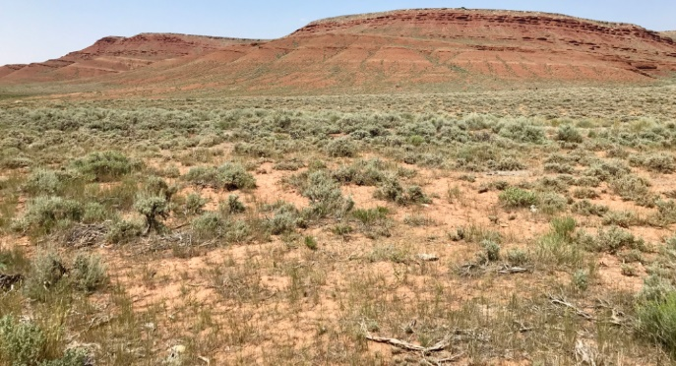
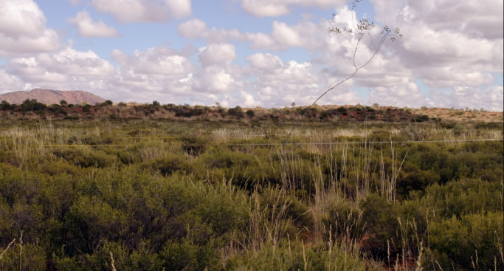
Introduction and Background

Wyoming and Australia, while far apart, share very similar vegetative communities. This occurrence can be explained through the understanding of a number of different ideas. The especially when it comes to amount of precipitation, are similar. The deserts of Australia and the basins of Wyoming both see low amounts of precipitation year-round, preventing the growth of certain types of plants. There are important differences. Australia is much hotter than Wyoming and its precipitation comes in the form of rain. Wyoming is much colder and most of its precipitation comes in the form of snow. However, both areas end up with the same problem: liquid water is often tough to come by.
To explain the reason for these dry conditions, several larger patterns must be understood. Much of the world’s desert regions can be found above and below the equator and are known as subtropical deserts. This occurs because at the equator, warm, moist air rises. As it rises, it releases this moisture, leading to the abundant rains found around the equator. This now cool, drier air moves away from the equator, eventually dropping in the subtropical regions. This dry air prevents the formation of clouds, leading to minimal rainfall and a dry, sun-beaten landscape. The Sahara, the deserts of the American Southwest, and most of the deserts of Australia are these types of deserts. A review of a global map shows this pattern quite well.
Deserts can form in other ways too. A rain shadow desert occurs around mountain ranges. A desert will form on the leeward side of a mountain, or the side that faces away from the wind. Winds will move moist air over a mountain range. As the moist air hits the mountains, it cools and releases moisture on the windward side, or the side facing the direction of the wind. When the air comes over the mountain, it is quite dry and descends. This dry air also prevents cloud formation, leaving the leeward side of the mountain dry. This occurs in the United States in Death Valley, where the Sierra Nevada Mountains capture moisture coming from the Pacific Ocean, leaving the eastern sides dry. It also explains some of the drier areas of Wyoming. Mountain ranges capture moisture, leaving the surrounding areas drier.
Another type of desert that also contributes to Wyoming’s dryness are interior deserts. These deserts form in areas deep inland. They form simply because moist air from oceans or large lakes lose moisture as they move inland. By the time they reach the most inland areas, they have very little moisture. The Gobi Desert is an example of a large inland desert. Wyoming certainly is impacted by its distance from the oceans and the Great Lakes.
The final type of desert are coastal deserts. These occur generally on the western side of continents. Although close to water, the cold ocean currents cool the air, preventing it from holding on to much moisture. The land near this air receives nearly any rain. An example of this is the Atacama Desert in Chile, which is the driest place on Earth!
Overall, these desert conditions favor plants with particular adaptations. These plants are adapted to dry weather and other harsh weather conditions such as high wind: deep roots, thick, waxy leaves or stems, wide instead of tall growth, and increased protection from predators, such as spikes, thorns, or secondary chemicals that make eating unpleasant (think the smelly components of sagebrush). The vegetation in Wyoming and Australia show many of these characteristics because they must endure similar challenges.

Information gathered from:
National Geographic. (n.d.). Desert. In National Geographic Resource Library. https://www.nationalgeographic.org/encyclopedia/desert/

Lesson Ideas

Below is written a framework for presenting the phenomenon and several potential lines of student-generated inquiry that may develop. You may use link to the Phenomenon_Map to explore these lines of inquiry. You can use the links on the map to jump to different lessons. Bookmarked sections of the paper will have links throughout this document for ease of navigation.

Presentation of Phenomenon

Activities | Rationale
Begin by having students go to gVeg. Have students choose map filters “Map” and “Biome”. Look at How_to_Adjust_Map for information on how to have students do this. Eventually, there will be a link, but for now, have students filter for just “desert/xeric shrubland”. Look here for tips on how to achieve this. | This is a first exploration into the gVeg platform for students. Before introducing the specific phenomenon, students can get a feel for the platform, its capabilities, and also begin to see some of the patterns that will be discussed in the lesson.
Begin by students exploring the data available. Have them focus on just the pictures and the map first. You may pose questions like this:  - What do you notice about the environments and locations of these pictures?  - What does it make you wonder?  - What does it remind you of? | Students have the chance to share their initial thoughts on the pictures. Hopefully, students begin to notice some of the similarities and differences between the vegetation in the pictures as well as begin to consider the geographic distribution of deserts and xeric shrublands. A note to possibly share with students. Just because some of these areas do not have pictures does not mean there is little vegetation there. gVeg is a growing platform and still has many areas that have not been well photographed.
Now, have students focus just on data points in Wyoming and Australia. You may begin by having them look generally at all of the pictures in these areas. Then, you may have them look at the specific pictures from Wyoming and Australia. Have them observe these pictures specifically and begin to pose the phenomenon question: “The vegetation in parts of Wyoming and Australia look pretty similar. They are very far apart. How is this possible?” You may encourage students to look at the graphs for this as well. The Walter-Lieth diagrams may be complicated for your students but see if they can determine any trends. A primer on these graphs is included. | Now, students can start to hone in on the specific phenomenon, specifically looking at the deserts of Wyoming and Australia and exploring why they look similar despite being so far away. This is also an opportunity to start to gather student questions and misconceptions. The information gathered here will be able to determine in which direction you take the lesson.
Field any ideas and questions students generate to explain the phenomenon. Record these somewhere the whole class can see. Depending on the responses, you may choose to pursue any line of inquiry you desire! Suggestions are below | Depending on how students respond, you may choose to investigate different lines of inquiry. This document supports a line of inquiry related to global patterns of desert formation. If students are more interested in exploring hemispheric differences in climate or plant adaptations, you may consider alternate lesson plans. While this may serve as a good entry point for those ideas, gVeg does not fully support lessons in those topics. See the Phenomenon Map below for more details.

Phenomenon Map

In the Phenomenon Map below, the green bubbles represent activities supported by gVeg in this document. In blue are ideas that may arise from students while presenting the phenomenon. However, gVeg does not directly support these investigations. Relevant performance expectations are included in the blue bubbles.
Phenomenon: How can Wyoming and Australia have similar vegetation despite their distance?
Why do locations in the Northern and Southern hemispheres have different temperature patterns in different months?
Related PE: MS-ESS1-1
Line of Inquiry: Global and Local Patterns of Desert Formation - Where do deserts occur? What global climatic patterns lead to desert formation?
How have plants adapted to these locations? What is happening at the genetic level?
Related PE: MS-LS3-1

Global and Local Patterns of Desert Formation
This lesson is intended for students to look at large patterns of desert formation as well as desert formation on smaller scales. Using the map on gVeg, they should notice that deserts occur along similar latitudes both above and below the equator. There are also deserts that do not fit this pattern, such as coastal deserts in Chile and the Gobi Desert. To attempt to explain their observations, students will research different types of deserts. They will use a combination of videos, articles, and data from gVeg. Students will present out their information to the class so each student can have interaction with the various types of deserts.
Performance Expectations | MS-ESS2-6. Develop and use a model to describe how unequal heating and rotation of the Earth cause patterns of atmospheric and oceanic circulation that determine regional climates.
Science and Engineering Practices | Developing and Using Models  Evaluate limitations of a model for a proposed object or tool. Use a model to predict and/or describe phenomena. Use a model to generate data to test ideas about phenomena in natural or designed systems, including those representing inputs and outputs, and those at unobservable scales.
Crosscutting Concepts | Patterns  Graphs, charts, and images can be used to identify patterns in data.  Systems and System Models  Models can be used to represent systems and their interactions—such as inputs, processes, and outputs. Models are limited in that they only represent certain aspects of the system under study.
Disciplinary Core Ideas | Weather and Climate:  Weather and climate are influenced by interactions involving sunlight, the ocean, the atmosphere, ice, landforms, and living things. These interactions vary with latitude, altitude, and local and regional  geography, all of which can affect oceanic and atmospheric flow patterns. The ocean exerts a major influence on weather and climate by absorbing energy from the sun, releasing it

Lesson Suggestions and Resources
Activities | Rationale
Allow students to access gVeg. Students toggle the “Biome” filter to start. See here for guidelines on how to set this up for students. | By toggling biomes on the map, students can begin to see the distribution of both deserts and other biomes throughout the globe. This sets up the next part in which students record observations on patterns for both desert biomes and other biomes.
Have students zoom out to look at the entire map. Have students also toggle “biome” on and off so they can see the satellite images of Earth. Provide them with this graphic organizer to guide their thinking. | The graphic organizer is set to scaffold student thinking. Ideally, students can begin to recognize a few patterns for desert biomes, namely that many deserts occur both above and below the equator. They may also notice some deserts that do not fit this description but share other characteristics (further inland, on western coasts, near mountain ranges).
Allow students to share their answers and wonderings with a partner. Collect whole class answers, recording important points. | This is an opportunity to determine the patterns students recognized and also any new questions that have arisen. There is also an opportunity to gauge student knowledge on other biomes and other observations they may have. This information may be useful when considering teaching patterns of other biomes.
Play this video for students. You may choose to frame the video as: “I found this video where someone give their ideas about how deserts form. Let’s see if this video can help explain some of our observations.” This will give some information on Hadley cells and why subtropical deserts form. After the video, prompt students to return to gVeg. Consider these questions:  - Can this idea explain the pattern deserts we see on the map? Why or why not?  - How does the Hadley cell effect account for some of the climates close to the equator?  - What other information would you like to use to find out more about deserts? | This video, while covering a great deal of information, does highlight some of the major principles that dictate why deserts occur where they do. Students may not absorb all of the information from the video and that is okay. They will have a chance to explore these deserts and their formations in more detail later in the lesson. The main focus is that through the video, students begin to gain an understanding that large, global and regional forces are at work forming deserts and that there is an explanation to the patterns they have observed on the map.
Next, students will get to explore the different types of deserts. They will ultimately create a short presentation about their type of desert. This allows students to communicate their information with the class. They may do so orally, visually, written, or with graphs/tables they find. Students should explain why their type of desert produces the climate patterns observed earlier on the gVeg map.  You may frame it like this: “We will now get to explore how four different types of deserts form. By exploring these deserts, we can attempt to explain the patterns we have been observing. You will be split into groups and research your desert. You must determine how your type of desert explains some of the patterns we have observed on the map. You will give a short presentation on your findings to the class.” | Students now have the opportunity to dive more deeply into different types of deserts. Students will focus only on one desert, but by having the class share information, students will be able to learn about all four major types of deserts.
Break students into four groups: Subtropical Deserts, Coastal Deserts, Rain Shadow Deserts, and Interior Deserts. Students will communicate findings on how these deserts form, providing evidence from various sources. They will begin looking at a gVeg data point that represents each type of desert. Those data points can be found below:  Subtropical Desert  Rain Shadow Desert  Coastal Desert  Interior Desert  They can start their investigation by looking at the photo, its climate data, and other information they can obtain from gVeg. Patterns from gVeg maps can be used as evidence for their final presentation. After exploring gVeg, allow students to pull resources on their own. Several resources are listed to get them started but students should obtain some resources on their own. Some helpful diagrams can be found in this document as well that may aid students. | This will probably be the longest part of the process as students have time to conduct their research. A focus here is getting students to use a variety of resources from which to gather evidence. The points on gVeg will be a critical piece in having a photo and data that represents a particular kind of desert. The resources and diagrams provided give some textual and visual representations, respectively. You may also choose to give students freedom to find resources on their own. This may be through a classroom or school library, the internet, or by giving them a chance to use networks at home. Regardless, students should be able to synthesize information from these sources in order to put together a cohesive presentation.
Provide students with time to present their findings. Tell students the focus should be using their peers’ evidence to explain their observations on deserts. You may give them this sheet to help record their thoughts from peer presentations. They will be returning to the gVeg map shortly. | As students present, the hope is that their peers begin to make connections to the patterns of deserts explored earlier in the lesson and ultimately connecting back to the phenomenon question.
Bring students back to the gVeg map. Prompt students with this: “We have now seen that four different types of deserts can form. Using this knowledge, identify one of each kind of desert on the map. Explain your reasoning with evidence from what we just learned.” It may be helpful for students to use the biome filter again. | This activity allows students to demonstrate their understanding from what they have just learned. Students should be able to point out the different types of deserts based on what their peers have shared with them. They may use the information recorded from the presentations.
Now that students have investigated how deserts have formed, allow them to return to the phenomenon question: “The vegetation in parts of Wyoming and Australia look pretty similar. They are very far apart. How is this possible?”. Record any new information, wonderings, and lines of inquiry. | Returning to the phenomenon question will allow you to see if students provide any new explanations, understandings, or questions. Student questions may lead you to engage with different topics, perhaps some suggested in the Phenomenon Map.

Resources
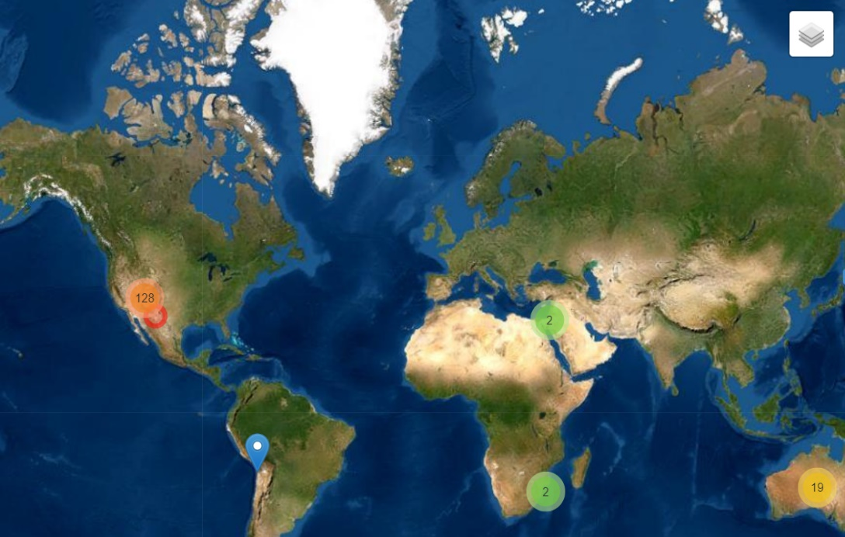
Changing Filters
Click here!

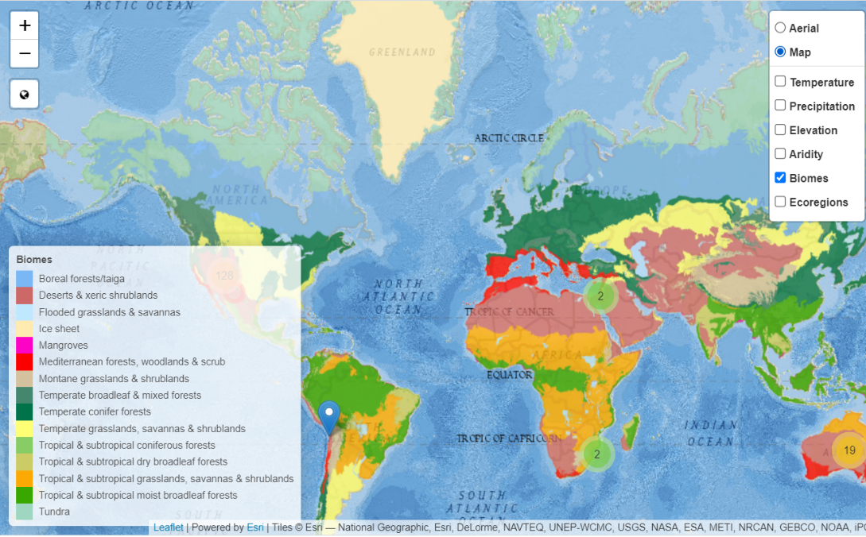
Check these two boxes!

Back to lesson

Observation Graphic Organizer
What did you observe? | What do these observations make you think about? | What questions do you have about each observation?
What do you observe about the location of different biomes in the world?

What do you observe about the location of desert biomes in the world?

What do you observe about the patterns of desert biomes?

What do you observe about other patterns of biomes on the global map?

Back to lesson

Desert Resources
Nat Geo Desert Types
ASU Deserts
NPS Deserts and Activities
Wild Classroom Deserts

Desert Diagrams
Hadley Cells and Subtropical Deserts
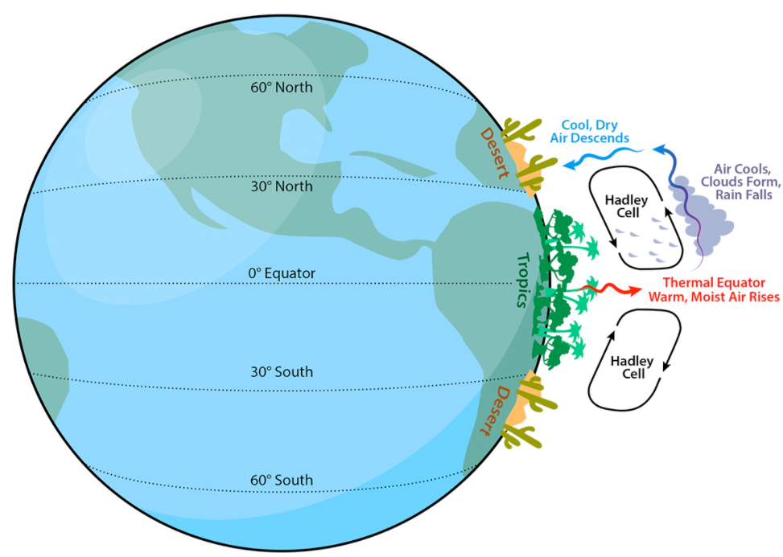
Image credit: https://askabiologist.asu.edu/explore/desert
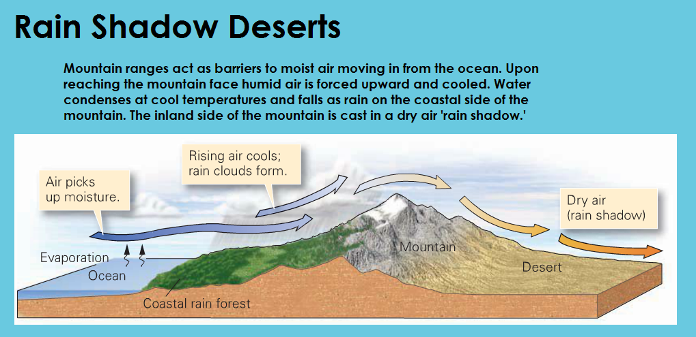
Image credit: https://sites.google.com/site/supercoolgeology/types-of-deserts/rain-shadow-deserts
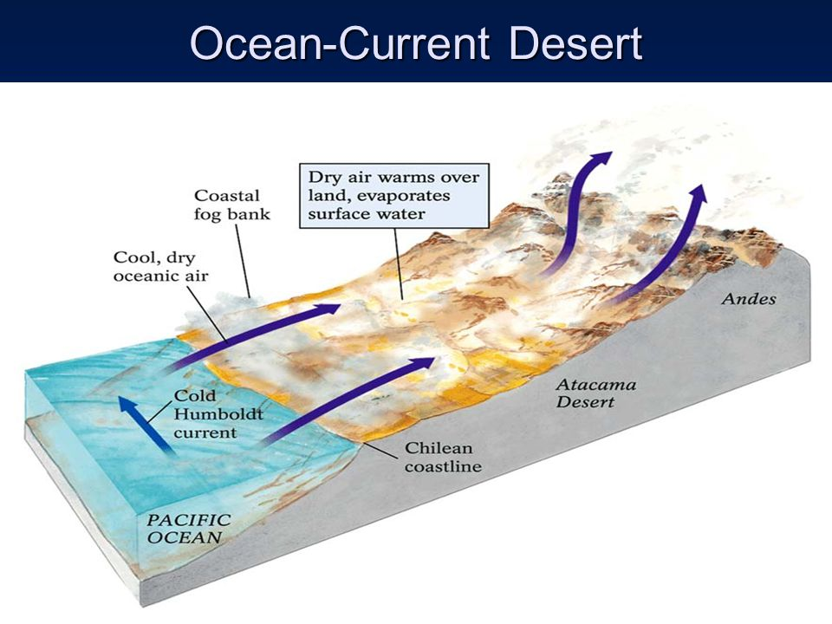
Image credit: https://slideplayer.com/slide/4320124/
Back to lesson

Presentation Information Sheet
Type of Desert | How does this desert form? | What is an example of this type of desert? | What other information did you find interesting about this type of desert?
Subtropical
Coastal
Interior
Rain Shadow

Back to lesson

References:
Moeller, K. (n.d.). Delving into deserts. Arizona State University. https://askabiologist.asu.edu/explore/desert

National Geographic. (n.d.). Desert. In National Geographic Resource Library. https://www.nationalgeographic.org/encyclopedia/desert/

National Park Service. (n.d.). Deserts. National Park Service. https://www.nps.gov/moja/learn/education/classrooms/upload/MDD-Unit-II-Deserts.pdf

The Wild Classroom. (n.d.). Desert Biome. The Wild Classroom. https://thewildclassroom.com/biomes/desert/

