Global Vegetation Project Exploration and Scavenger Hunt
Name: ____________________
Welcome! This little scavenger hunt will help you familiarize yourself with the Global Vegetation Project. Once you have the platform open, complete the tasks below!
- Take 60 seconds to find the most interesting, surprising, or curiosity-inspiring photo you can! Use the tasks below to figure out as much as you can about this photo and why it inspired such curiosity.
- What information can you get from the “Photo” tab? List anything you find below.

- For the same picture, click on the “Climate diagrams” tab. What information can you get from this tab? List anything you find below.

- Click on the “Filters” tab. Adjust some of the sliders. What happens when you move the sliders? How might this feature be useful?

- What did you learn about your photo? Why do you think it was so interesting to you?

Return to the map. Change the filters as shown in the picture below.

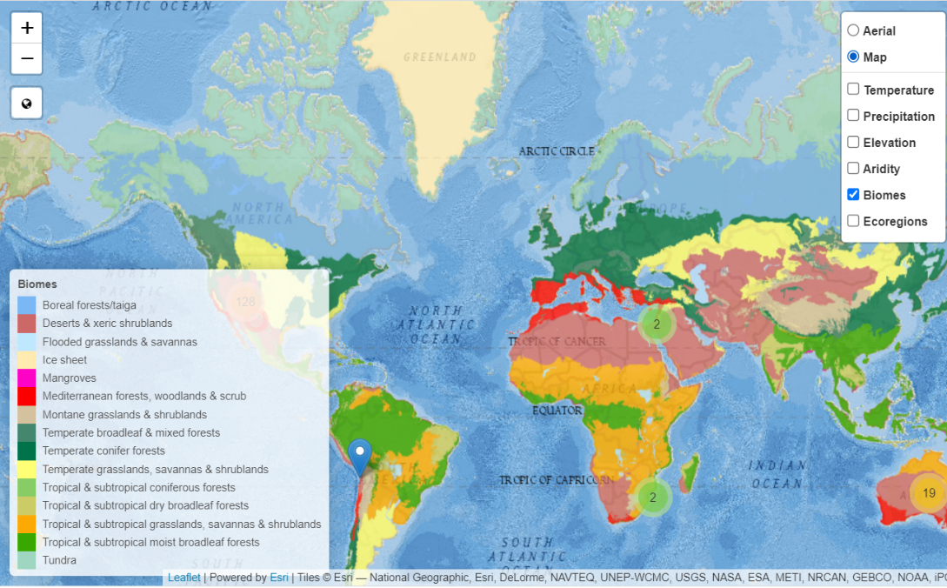
Check these two boxes!

Explore the different biomes for 60 seconds. In your own words, what do you think a biome is?

Use the biome filter to fill out the table on the next page. Record what you notice, what you wonder, and what these biomes remind you of.

 | Notice | Wonder | Remind
Explore the biomes across the whole WORLD.
Explore the biomes across the UNITED STATES. (Don’t forget Alaska and Hawaii!)
Explore the biomes across WYOMING.
Explore 3 biomes that are interesting to you, from anywhere.
Now it’s time for a bit of a scavenger hunt! Fill out the tasks below using the Global Vegetation Project Platform.

Find the picture that is closest to your home. Write its location.
A picture has a location in Madagascar Avenue of Baobabs in Toliary, Madagascar. Who took this picture?
Find a photo in Japan. Write its ecoregion.
Use the “Temperature” filter on the map. What area has the coldest temperatures in the world? Write the location of one of the pictures there.
Use the “Precipitation” filter on the map. What area(s) get the most precipitation? Click on one of the photos there and describe what you see.
Pick a picture that is far towards the North Pole. What is the coldest month of the year there? (Hint: Use the “Climate diagrams” and look at the red line)
Pick a picture that is far towards the South Pole. What is the warmest month of the year there? (Hint: Use the “Climate diagrams” and look at the red line)
Find the picture on the platform that has the highest elevation. Write its location. (Hint: it is not above 5000 m)
Find the picture on the platform that has the lowest elevation. Write the name of one dominant plant species found there.

