This document provides a lesson outline using a phenomenon from the Global Vegetation Project (gVeg). Our intent is to provide you with a phenomenon that you can use to stimulate discussion and lessons within your classroom. Bookmarks are present throughout the document to ease your navigation. Your class may take the phenomenon in many directions; we aim to anticipate a few of those directions and provide resources and ways to use gVeg. We also recognize that each educator has specific styles, student needs, time restraints, and outcomes to hit. This is intended to be a resource that you can fit to your needs as an educator while sparking student interest and joy. Use this resource in whatever way best suits you!

Overarching Phenomenon

Why do ungulates (hooved mammals) live in certain habitats?

Lesson Summary

Students view habitat maps of various North American ungulate species and must provide an explanation as to why species occupy certain habitat ranges. Using gVeg, students may investigate the vegetation in these ranges or the climate in these ranges. Students can begin to make connections to the types of plants ungulates consume and how plant distribution impacts these animals. They may also make connections to climate, observing that some habitats may be too hot, too cold, too dry, or too wet for certain species.

Introduction and Background (This is written in student friendly language as well. Bolded words can be used as vocabulary).

When you’re heading to school, do you ever see animals on the side of the road or sidewalk? Do you ever wonder why they are there? Maybe you also wonder why you don’t see those animals in other places, like at your home. If you’ve had these thoughts, you’re not alone! Trying to figure out why animals are in some places and not in others is a BIG question for scientists like ecologists, wildlife biologists, and conservation scientists. One of the reasons this is such a big deal is that knowing this very important information helps us to understand how and where to protect and conserve species. If you like to use fancy words, understanding where species are and why is the focus of a field of biology called biogeography. We’ll learn more about this topic through this lesson!
Let’s dig into this question using a group of species called ungulates. Ungulates are mammals that have hooves, which include species like cows, horses, deer, moose, and many more. Most living species have 1, 2, or 3 hooves. Fun fact: hooves are their fingernails, so when you see deer or horses walking, they’re actually walking on their fingernails! There are over 250 species of ungulates throughout the world, and they range from weighing between 5 tons (white rhinoceros and hippopotamus) and 3 pounds (Java mouse-deer). They all are herbivores, which means that they live by only eating plants. Because of the diversity in the biology of the different ungulate species and plants differ across the world, what ungulates eat also differs! Ungulates live in all sorts of habitats throughout the world, from the soaking wet rainforests in Central America to the deserts in western North America to the tops of mountains in Mongolia! That’s a lot of diversity in size, what they eat, and more!
Why do we mention these different forms of diversity? Because they are some of the factors that shape where animals live! The size of an animal influences how tolerant it is of heat. Big animals like moose (moose can weigh up to 1600 pounds!!) tend to overheat, so they need places that are either cooler in temperature or have many places where they can rest in the water or shade to cool off. Their size also influences what predators could eat them. White-tailed deer are small and somewhat easy for species like mountain lions to catch and eat, but moose, because they’re so big and burly, are very hard to catch!
Some species have super abilities that also help shape where they live. Bighorn sheep lambs (young bighorn sheep) can run up and down steep cliffs at only a day or 2 old! That’s incredible, and not many other ungulates can do that! Their athletic, mountaineering abilities let them live at high-elevations or on cliffs. Pronghorn are the fastest land mammal in North America, and can run up to 60 miles an hour! This means that they are very good at running away from predators, but only if they have fairly flat ground. Many of these special abilities are adaptations, which are characteristics or behaviors that help animals to survive and produce offspring.
One of the biggest factors that determines where a species lives is what it eats. Some ungulate species are browsers, which means that they tend to “browse” or very delicately eat certain parts of plants, and some species are grazers, which means that they tend to put their heads down and eat whatever they can fit in their mouths. Browsers tend to eat flowers, grasses, and shrubs, and tend to like habitats that have lots of those different types of plants to eat. Grazers, however, tend to like habitats that have lots of grasses, and tend to like habitats that have lots of different types of plants to eat. Ecology is pretty complicated, and some species are a blend of the browsers and grazers, and we haven’t really figured out where to place them on the spectrum quite yet!
All of these factors, and many more, all work together to form species distributions, also known as their ranges, which is the region that a species can be found in. Some species are restricted in their distributions, which means they are only found in a few places. In contrast, other species are widespread, which means that they are found in many places. Some species are in the middle! Understanding the biology of a species helps us understand where they live, and similarly, understanding where a species lives helps us understand their biology.
You may choose to study any of the ungulates below. You may choose to dive deeply into one species or look at several to compare their ranges, diets, behaviors, and other characteristics.

Moose (Alces americanus)
White-tailed deer (Odocoileus virginianus)
Mule deer (Odocoileus hemionus)
Pronghorn (Antilocapra americana)
Elk (Cervus elaphus)
Bighorn sheep (Ovis canadensis)
Bison (Bos bison)* Note: The distribution of bison have been more severely impacted by human activity than the other species listed and are thus not an accurate representation of an organism’s relationship with the environment alone. A separate lesson for bison distribution is recommended, with some provided resources later in this document.

Below is written a framework for presenting the phenomenon and the lines of inquiry you may choose to take with your students. The Phenomenon_Map below provides several lines of inquiry that your students may generate. You may choose to go in any of those directions. Allow the students to guide the path of your teaching. Following the map is a description for the presentation of the phenomenon and potential lessons.

Phenomenon Map

The figure below maps a potential course for engaging students with the phenomenon and given material. The green bubbles are the activities described in this document and are supported by gVeg. You may choose to engage in these lines of inquiry in any order you choose. The blue bubbles are potential lines of inquiry that this activity can serve as a starting point for; however, gVeg itself does not support these investigations directly.
Phenomenon: Why do ungulates live in certain habitats?
Inquiry A: Exploring Vegetation in Ungulate Ranges
Inquiry B: Exploring Weather and Precipitation in Ungulate Ranges

Human Impacts on Ungulate Populations and Management

Presentation of Phenomenon

Activities | Rationale
To begin, you may have students consider the large animals that live around them. Ask students to consider any of the large animals that live in the area and what they eat. Students may think independently or work in pairs. When finished, allow students to share their answers. | This activity gets students thinking about the large animals around them and also provides information for you to use. For example, if students seem interested in discussing pronghorn and mule deer, you may steer the lesson towards those animals.
Tell students they will be exploring the habitats of different ungulates (you may introduce the term here). Based on student interest or your own learning agenda, provide students with a habitat map of a given species. These maps show what habitats these animals can be found in throughout the United States. You may choose to have the whole class focus on one or two species, or potentially have groups of students study a variety of species. Have students consider the following questions:  - What patterns do you notice in this species distribution?  - What type of habitats do you think this species prefers?  - What type of habitats is this species not found in? Why do you think it is not found there?  All habitat maps are linked below.  - Mule deer  - Moose  - White-tailed deer  - Elk  - Pronghorn  - Bighorn Sheep  - Bison *See note above about bison and human interactions. This map could be a good point of comparison if you wish to explore the human impact line of inquiry. | The distribution map serves as the phenomenon in this lesson. Students can observe the distribution of these ungulates throughout the United States. They will then be tasked with being able to explain why these ungulates live in these certain habitats. This initial phase of exploration is meant to generate thoughts, ideas, and questions for students. Also, consider printing out copies of the maps. This way, students can have a hard copy of the habitat range map and then can have the gVeg map on their electronic device for the next activity.
After students have had the opportunity to explore and share, pose the phenomenon question: “Why do [insert ungulate name] live in certain habitats?” Record any and all student ideas and questions. Have these visible for the whole class. | Students will now be introduced to the overarching question that they need to explain. By also recording student answers, you may determine what other lines of inquiry may be relevant for students. If students seem interested in the types of vegetation and diets of the animals, consider starting with Inquiry A. If students seem interested in the climate and weather of these ranges, consider Inquiry B. If the lines of inquiry shift more towards human activity and development, consider investigating the resources found here.

Lesson Ideas

Inquiry A: Exploring Vegetation in Ungulate Ranges

Below are the Performance Expectations, Science and Engineering Practices, Crosscutting Concepts, and Disciplinary Core Ideas present in this lesson. The color coding is in line with the Next Generation Science Standards (NGSS). The color coding is consistent throughout the document, reflecting where each of the three dimensions are present.

Performance Expectations | MS-LS2-1. Analyze and interpret data to provide evidence for the effects of resource availability on organisms and populations of organisms in an ecosystem.  MS-LS2-2. Construct an explanation that predicts patterns of interactions among organisms across multiple ecosystems.
Science and Engineering Practices | Analyzing and Interpreting Data  Use graphical displays (e.g., maps, charts, graphs, and/or tables) of large data sets to identify temporal and spatial relationships. Analyze and interpret data to provide evidence for phenomena.  Constructing Explanations and Designing Solutions  Apply scientific ideas, principles, and/or evidence to construct, revise and/or use an explanation for real-world phenomena, examples, or events. Construct an explanation that includes qualitative or quantitative relationships between variables that predict(s) and/or describe(s) phenomena.
Crosscutting Concepts | Cause and Effect  Cause and effect relationships may be used to predict phenomena in natural or designed systems.  Patterns  Graphs, charts, and images can be used to identify patterns in data. Patterns can be used to identify cause-and-effect relationships.
Disciplinary Core Ideas | Interdependent Relationships in Ecosystems  Mutually beneficial interactions, in contrast, may become so interdependent that each organism requires the other for survival. Although the species involved in these competitive, predatory, and mutually beneficial interactions vary across ecosystems, the patterns of interactions of organisms with their environments, both living and nonliving, are shared. Organisms, and populations of organisms, are dependent on their environmental interactions both with other living things and with nonliving factors

Lesson Progression

In this lesson, students will compare the maps of habitat ranges for ungulates with the photos from the Global Vegetation Project. Students will analyze photos of vegetation across the ungulate species’ range, determining any patterns in types of vegetation. They will also look at locations throughout the range the ungulate does not occupy, also looking for patterns. Students will use this data to build an explanation as to why ungulates are only found in particular areas, focusing on the types of vegetative species present. At the end, students will need to draw the ungulate in a habitat where it may be found.

Activities | Rationale
Have students keep the ungulate maps from the phenomenon presentation (if you chose to print them out, have students keep the maps). Again, this can be done with one species, two species, or multiple species and their respective maps. Allow students to open up gVeg. Have them trigger the “Map” filter and zoom in to the United States on the map. Instructions can be found here. | This sets students up for the main portion of this activity. Students will be comparing the habitat range map to the map on gVeg. If you have printed out hard copies of the habitat maps, you may have students work individually. If you have not, allow students to work in pairs so that they have two devices. This way, students can have gVeg and the habitat map up at the same time and do not have to toggle between them.
Tell students that they will be able to explain a piece of the phenomenon question by looking at the patterns of vegetation from the ecosystems where their ungulate lives and does not live. Students must look at five data points on gVeg within the species ecosystem range and three data points outside of their range. Based on the range map, have students only look at points in the U.S. An example comparison is provided here. For each point, they must look closely at the photo of the vegetation. For points within the range, they must describe what the vegetation looks like, what they think the ungulate might eat, and why they think the ungulate could survive well in that habitat. For the points outside of the range, they will describe the plant life and provide an explanation as to why the ungulate would not survive there. Students may use this graphic organizer to arrange their thoughts. | This activity represents the bulk of the data collection for this activity. Students will be able to look at photos within the ungulate’s range and describe the vegetation there. Students should be able to generate thoughts on what the ungulate might eat and why it might prefer this habitat. It is also important that students look at photos outside of this ungulate’s range. Students will begin to generate ideas about why it might not survive well in these areas, contributing to the explanation of why ungulates only live in certain areas. While you may allow students to use the entire United States for this piece, you may also choose to restrict it to Wyoming, the Rocky Mountains, or another range of your choosing.
When students have collected their data, have them reflect on the following questions (found at the bottom of the graphic organizer):  - What patterns in vegetation do you see from the photos within the ungulate’s range?  - What patterns in vegetation do you see from the photos outside the ungulate’s range?  - How do you think the patterns of vegetation affect the ungulate’s lifestyle?  This provides a way for students to analyze their data. For the first two pieces, students must identify evidence from their collected data to support their claims. | These questions allow students to start analyzing their data. The data points should give them a general idea of the types of habitats these ungulates prefer and which they do not. Students can start digging into the crosscutting concepts within the lesson as well, identifying patterns and also considering cause and effect. This also gives students an opportunity to connect their claims to the evidence they found throughout the activity.
Once students have finished their personal reflection, have them share in pairs or small groups. Once they have finished sharing, tell students they may revise some of their answers and explanations. | This provides students the opportunity to share their knowledge, defend their claims, listen to other students, and then adjust the explanations they had. As each student may be looking at different sets of data points, students may have different interpretations and information. Gleaning new knowledge from peers is a process that may lead to an adjustment in student’s own work, an important process in science and an acknowledgment that information can always be adjusted in light of new evidence.
Option: You may have students conduct research on the ungulate they have been studying. This is an opportunity for students to collect more data on their ungulate and to confirm whether the patterns concerning habitat and survival were accurate. They may also take new interpretations from this research. You may have students look for resources on their own. A few resources to get them started can be found below:  Animal Diversity Web  A-Z Animals | This option provides an opportunity for students to dive a little more deeply into the organisms they have been studying and they may be able to make connections to the observations made in the lesson. Oftentimes, it can be reassuring for students to have drawn their own conclusions (say, about the vegetation an ungulate prefers) and have that confirmed by professional sources. It may also serve as ways for students to think differently about the lesson and the approach they took. On a final note, allowing students to do a bit of research and source information builds towards the science and engineering practice Obtaining, Evaluating, and Communicating Information.
Option: You may have students repeat this exercise (or potentially shorten it) for a different ungulate species. If you had students look at more than one species, you may have them compare data between ungulate species. Students can begin looking for patterns that show up between species and predict how these organisms may interact in their environments. Students will have further practice in analyzing larger amounts of data and using that data to explain phenomena. | This can be a valuable exercise in comparing data sources and exploring interactions within ecosystems more deeply. It is important students understand that multiple organisms are using the resources within an environment and that there may be overlap in how these organisms behave. You may even choose to use this as an entryway into discussing animal organization as a whole, beginning with ungulates as a larger group. Students could look at the similarities present across several species and compare that to other groups (carnivores, for example).
Concluding Questions/Activity: Whether you choose to explore some of the options above or not, tell students they must draw their ungulate in an environment it is suited for. It must have vegetation that they observed from gVeg. This will allow students to synthesize much of the data they have analyzed throughout this activity. Also, have students think through the following questions that address the cause-and-effect nature of relationships in ecosystems. There is also an opportunity to transition to discussions of climate change and how climate change may impact ungulate populations. You may use some of the questions below or others that explore relationships you find relevant:  - If the plant communities began to change in your ungulate’s range, what do you think would happen to the ungulate population?  - If the population of your ungulates doubled, what impact might this have on the landscape?  - Imagine the population of wolves (an ungulate predator) in the United States continues to increase. What impact might this have on your ungulate population? In turn, what impact might this have on plant communities?  - Climate change is beginning to shift plant communities. How do you think climate change might impact your particular ungulate species? | The drawing activity allows for a check of understanding for some of the important pieces from this activity. They should be able to recreate the types of landscapes and vegetation that these animals live in. These questions dig into some of the larger interactions occurring in ecosystems where these ungulates live. Students should have some ideas based on the evidence they collected in this activity. Now, they can apply those ideas even further in making predictions about what may happen if something changes. Students can begin to think about changes to ecosystems that come from both living and non-living sources.
Finally, have students return to the initial phenomenon question: “Why do [insert ungulate name] live in certain habitats?” Record any student explanations, new ideas, or new lines of questions that they share. | By returning to the phenomenon question, you may track student understanding and growth. You can also determine what new lines of inquiry may interest or excite them. If the conversation shifts more towards climate and weather, you may choose to incorporate Inquiry B (although you may choose to modify it). If conversation steers more towards human interaction/management, you may choose to pursue a lesson on that. Some resources can be found here.

Inquiry B: Exploring Temperature and Precipitation in Ungulate Ranges

Below are the Performance Expectations, Science and Engineering Practices, Crosscutting Concepts, and Disciplinary Core Ideas present in this lesson. The color coding is in line with the Next Generation Science Standards (NGSS). The color coding is consistent throughout the document, reflecting where each of the three dimensions are present.

Performance Expectations | MS-LS1-5. Construct a scientific explanation based on evidence for how environmental and genetic factors influence the growth of organisms.  MS-LS2-2. Construct an explanation that predicts patterns of interactions among organisms across multiple ecosystems.
Science and Engineering Practices | Analyzing and Interpreting Data  Use graphical displays (e.g., maps, charts, graphs, and/or tables) of large data sets to identify temporal and spatial relationships. Analyze and interpret data to provide evidence for phenomena.  Constructing Explanations and Designing Solutions  Apply scientific ideas, principles, and/or evidence to construct, revise and/or use an explanation for real-world phenomena, examples, or events. Construct an explanation that includes qualitative or quantitative relationships between variables that predict(s) and/or describe(s) phenomena.
Crosscutting Concepts | Cause and Effect  Cause and effect relationships may be used to predict phenomena in natural or designed systems.  Patterns  Graphs, charts, and images can be used to identify patterns in data. Patterns can be used to identify cause-and-effect relationships.
Disciplinary Core Ideas | Interdependent Relationships in Ecosystems  Mutually beneficial interactions, in contrast, may become so interdependent that each organism requires the other for survival. Although the species involved in these competitive, predatory, and mutually beneficial interactions vary across ecosystems, the patterns of interactions of organisms with their environments, both living and nonliving, are shared. Organisms, and populations of organisms, are dependent on their environmental interactions both with other living things and with nonliving factors  Growth and Development of Organisms  Local conditions affect the growth of the adult organisms.

Lesson Progression

In this lesson, students will compare the maps of habitat ranges for ungulates with photos from the Global Vegetation Project. Students will analyze graphs of temperature and precipitation data across the ungulate species’ range, determining any patterns. They will also look at locations throughout the range the ungulate does not occupy, also looking for patterns. Students will use this data to build an explanation as to why ungulates are only found in particular areas, focusing on the climate of those regions. This activity is nearly parallel in structure to Inquiry A, but instead of focusing on vegetation, like Inquiry A does, this focuses on environmental and climatic factors. This line of inquiry can provide more of an opportunity in exploring animal adaptations to climate and the impacts of climate change.

Activities | Rationale
Have students keep open the ungulate maps from the phenomenon presentation. Again, this can be done with one species, two species, or multiple species and their respective maps. Allow students to open up gVeg. Have them trigger the “Map” filter and zoom in to the United States on the map. Instructions can be found here. | This sets students up for the main portion of this activity. Students will be comparing the habitat range map to the map on gVeg. If you have printed out hard copies of the habitat maps, you may have students work individually. If you have not, allow students to work in pairs so that they have two devices. This way, students can have gVeg and the habitat map up at the same time and do not have to toggle between them.
Tell students that they will be able to explain a piece of the phenomenon question by looking at the patterns of temperature and precipitation data from the ecosystems where their ungulate lives and does not live. Students must look at five data points on gVeg within the species ecosystem range and three data points outside of their range. Based on the range map, have students only look at points in the U.S. An example comparison is provided here. For each point, they must look at the temperature and precipitation data provided by the Walter-Lieth diagrams (a guide on how to interpret these can be found on the lesson resources page). For points within the range, they must describe what they notice about the temperature and precipitation data, and why they think the ungulate could survive well in that habitat. For the points outside of the range, they will describe the temperature and precipitation profile and provide an explanation as to why the ungulate would not survive there. Students may use this graphic organizer to arrange their thoughts. | This activity represents the bulk of the data collection for this activity. Students will be able to look at photos within the ungulates range and describe the temperature and precipitation there. Students should be able to generate thoughts on what adaptations the ungulate might have to survive in this area. It is also important that students look at photos outside of this ungulate’s range. Students will begin to generate ideas about why it might not survive well in these areas, contributing to the explanation of why ungulates only live in certain areas. While you may allow students to use the entire United States for this piece, you may also choose to restrict it to Wyoming, the Rocky Mountains, or another range of your choosing.
When students have collected their data, have them reflect on the following questions (found at the bottom of the graphic organizer):  - What patterns in temperature and precipitation do you see from the photos within the ungulate’s range?  - What patterns in temperature and precipitation do you see from the photos outside the ungulate’s range?  - How do you think the patterns of temperature and precipitation affect the ungulate’s lifestyle? How might this impact behaviors like migration?  This provides a way for students to analyze their data. For the first two pieces, students must identify evidence from their collected data to support their claims. | These questions allow students to start analyzing their data. The data points should give them a general idea of the types of climates these ungulates prefer and which they do not. Students can start digging into the crosscutting concepts within the lesson as well, identifying patterns and also considering cause and effect. This also gives students an opportunity to connect their claims to the evidence they found throughout the activity. You may also choose to start discussing behavioral adaptations like migration, which would be more relevant for species like elk and pronghorn.
Once students have finished their personal reflection, have them share in pairs or small groups. Once they have finished sharing, tell students they may revise some of their answers and explanations. | This provides students the opportunity to share their knowledge, defend their claims, listen to other students, and then adjust the explanations they had. As each student may be looking at different sets of data points, students may have different interpretations and information. Gleaning new knowledge from peers is a process that may lead to an adjustment in student’s own work, an important process in science and an acknowledgment that information can always be adjusted in light of new evidence.
Option: You may have students conduct research on the ungulate they have been studying. This is an opportunity for students to collect more data on their ungulate and to confirm whether the patterns concerning habitat and survival were accurate. They may also take new interpretations from this research. You may have students look for resources on their own. A few resources to get started can be found below:  Animal Diversity Web  A-Z Animals | This option provides an opportunity for students to dive a little more deeply into the organisms they have been studying and they may be able to make connections to the observations made in the lesson. Oftentimes, it can be reassuring for students to have drawn their own conclusions (say, about the vegetation an ungulate prefers) and have that confirmed by professional sources. It may also serve as ways for students to think differently about the lesson and the approach they took. On a final note, allowing students to do a bit of research and source information builds towards the science and engineering practice Obtaining, Evaluating, and Communicating Information.
Option: You may have students repeat this exercise (or potentially condense it) for a different ungulate species. If you had students look at more than one species, you may have them compare data between ungulate species. Students can begin looking for patterns that show up between species and predict how these organisms may interact in their environments. Students will have further practice in analyzing larger amounts of data and using that data to explain phenomena. | This can be a valuable exercise in comparing data sources and exploring interactions within ecosystems more deeply. It is important students understand that multiple organisms are using the resources within an environment and that there may be overlap in how these organisms behave. You may even choose to use this as an entryway into discussing animal organization as a whole, beginning with ungulates as a larger group. Students could look at the similarities present across several species and compare that to other groups (carnivores for example)
Concluding Questions: Whether you choose to explore some of the options above or not, have students think through the following questions that address the cause-and-effect nature of relationships in ecosystems. There is also an opportunity to transition to discussions of climate change and how climate change may impact ungulate populations. You may use some of the questions below or others that explore relationships you find relevant:  - Climate change is beginning to shift plant communities. How do you think climate change might impact your particular ungulate species? How might their range change if the climate begins to get warmer? | These questions dig into some of the larger interactions occurring in ecosystems where these ungulates live. Students should have some ideas based on the evidence they collected in this activity. Now, they can apply those ideas even further in making predictions about what may happen if something changes. Students can begin to think both about changes to ecosystems that come from both living and non-living sources.
Finally, have students return to the initial phenomenon question: “Why do [insert ungulate name] live in certain habitats?” Record any student explanations, new ideas, or new lines of questions that they share. | By returning to the phenomenon question, you may track student understanding and growth. You can also determine what new lines of inquiry may interest or excite them. If you chose to do explore this line of inquiry and discussion turns to the actual vegetation in these areas, consider exploring Inquiry A (although you may wish to modify). If discussion turns more towards human impacts and management of ungulate populations, consider exploring the resources provided here.

Human Impacts on Ungulate Populations: Resources
In exploring ungulate ranges (especially for that of bison), students may generate questions on how humans and ungulate populations interact. While gVeg does not provide direct support for this investigation, the lines of inquiry in this resource can serve as a jumping off point. If students are interested in exploring this relationship, consider using some of the resources below. * Note: some of this information is explicit and details the violence associated with the extermination of bison and its implications on the dislocation and disenfranchisement of indigenous peoples. Please screen this information before use to determine whether it is appropriate for your students.
Bison
- Bison Timeline
- Bison Management in Yellowstone - NPS
- Bison Extermination and Native Populations
- Varied Perspectives on Bison Reintroduction
- Bison Reintroduction for Northern Arapaho
- Short Explainer on Current Bison Management
- Brucellosis in Jackson Hole
Elk
- Elk Management in Montana
- Perspectives and History on Elk Management - NPS
Moose
- Moose Management Canada
- Moose Management Alaska
- Moose, Ticks, and Climate Change

Resources
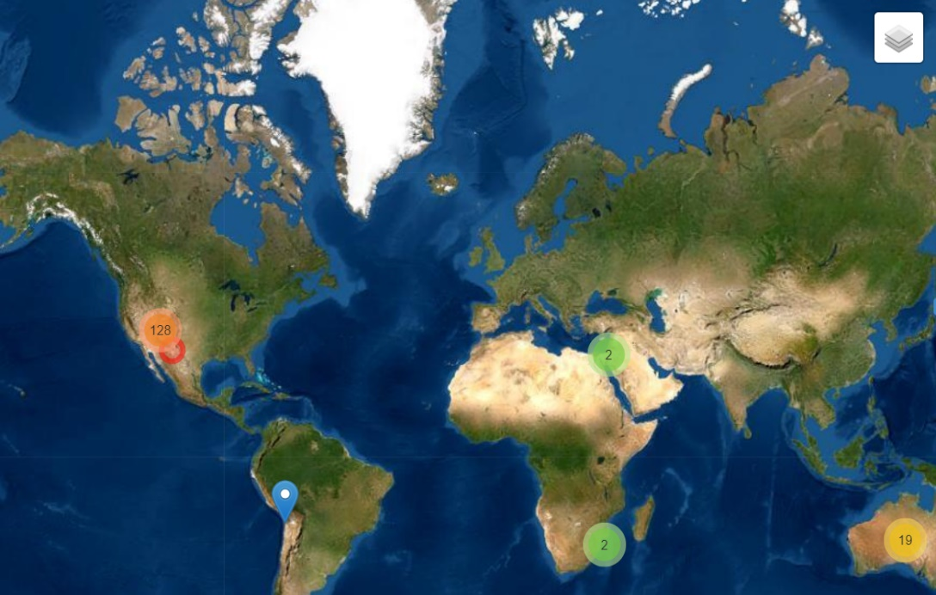
Set Map Filter
Click here! herehere!

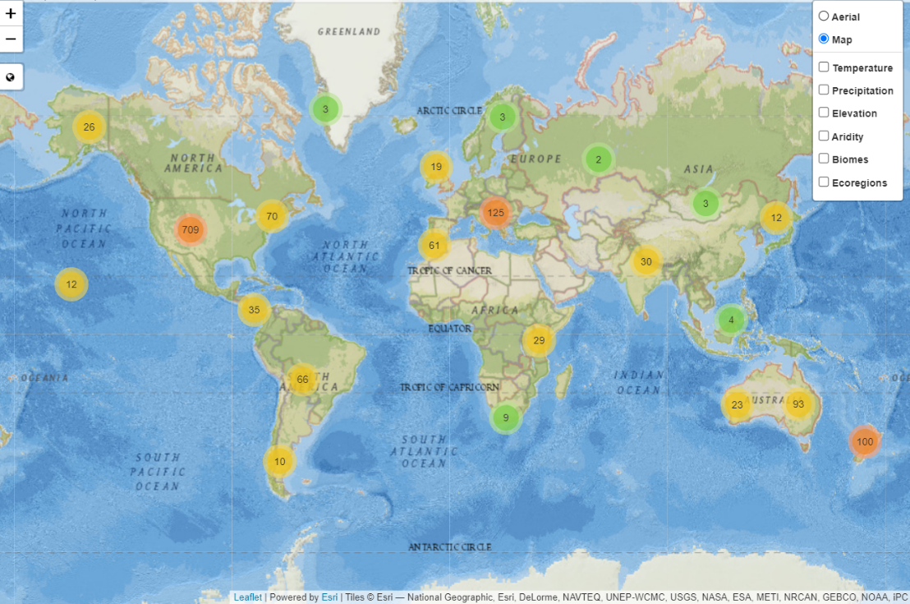
Then click here! herehere!
Back to Inquiry A
Back to Inquiry B
Data Point Comparison Example
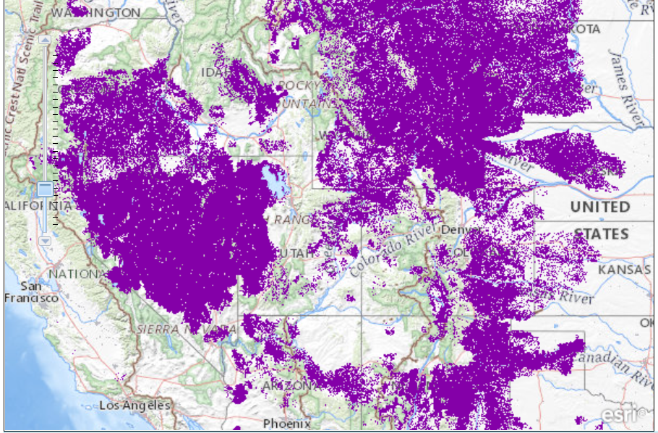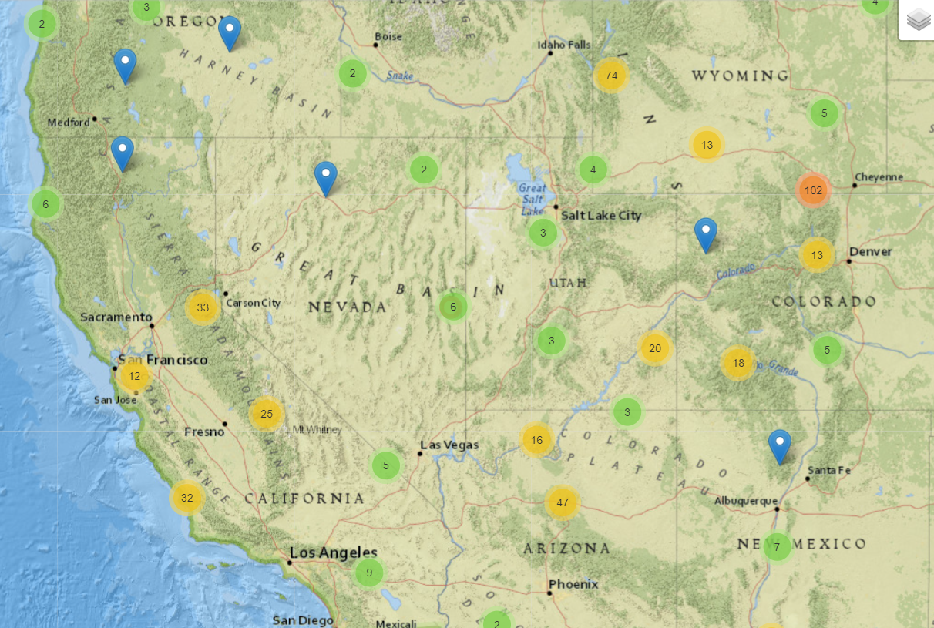
Students can explore gVeg photos/climate data here!
Students identify this part of range
Back to Inquiry A
Back to Inquiry B
Vegetation Graphic Organizer
Ungulate Species:
Photos Within Range | What types of plants do you see in this photo? | Based on the photo, what might the ungulate eat? |  |  | Why do you think the ungulate would survive well in this habitat?
Point 1
Point 2
Point 3
Point 4
Point 5
Photos Outside Range | What types of plants do you see in this photo? |  |  | Why do you think the ungulate is not found in this habitat?
Point 1
Point 2
Point 3
What patterns of vegetation do you see from photos within the ungulate’s range? | Your Claim: |  | Your Evidence:
What patterns of vegetation do you see from the photos outside the ungulate’s range? | Your Claim: |  | Your Evidence:
How do you think the patterns of vegetation affect the ungulate’s lifestyle? | Your Claim: |  | Your Evidence:

Back to Inquiry A

Temperature and Precipitation Graphic Organizer
Some helpful tips for interpreting these graphs: Generally, it will snow when average temperatures are below 2°C. Averages from 2-4°C may have mixes of rain and snow. Averages 5°C and above indicate mostly rain. Remember, precipitation is measured in mm. For context, an area is classified as a desert if it gets 250 mm or less of precipitation in a year. Forests and grasslands can have precipitation ranges from 250 mm to 2000 mm per year.
Ungulate Species
Photos Within Range | What is the temperature like in this area throughout the year? Is it generally hot, cold, or does it shift throughout the year? | Based on the temperature and precipitation data, what do you think this area is like? Is it wet/dry? Does it have mainly rain or snow? |  |  | Why do you think the ungulate would survive well in this habitat?
Point 1
Point 2
Point 3
Point 4
Point 5
Photos Outside Range | What type of climate exists in this area? |  |  | Why do you think the ungulate is not found in this habitat?
Point 1
Point 2
Point 3
What patterns of temperature and precipitation do you see from points within the ungulate’s range? | Your Claim: |  | Your Evidence:
What patterns of temperature and precipitation do you see from the photos outside the ungulate’s range? | Your Claim: |  | Your Evidence:
How do you think the patterns of temperature and precipitation affect the ungulate’s lifestyle? How do you think this impacts behavior like migration? | Your Claim: |  | Your Evidence:

Back to Inquiry B

