This document provides a lesson outline using a phenomenon from the Global Vegetation Project (gVeg). Our intent is to provide you with a phenomenon from gVeg that you can use to stimulate discussion and lessons within your classroom. Your class may take the phenomenon in many directions; we aim to anticipate a few of those directions and provide resources and ways to utilize gVeg. We also recognize that each educator has specific styles, student needs, time restraints, and outcomes to hit. This is intended to be a resource that fits your needs as an educator while sparking student interest and joy. Use this resource in whatever way best suits you!

Overarching Phenomenon: The deserts and plains of Wyoming and Australia look very similar despite being very far from each other. How is this possible?
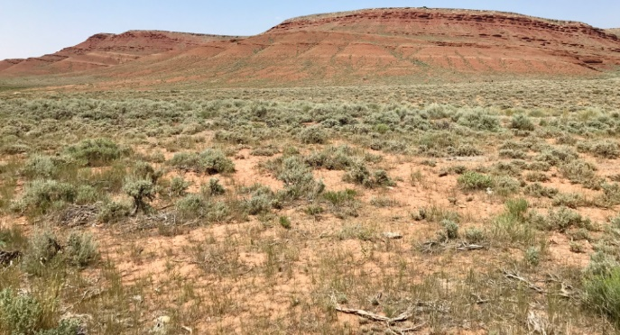
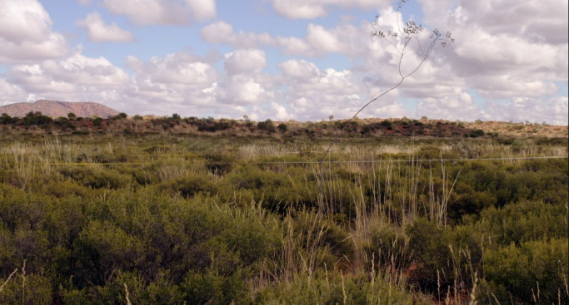
Introduction and Background

Wyoming and Australia, while far apart, share very similar vegetative communities. This occurrence can be explained through the understanding of a number of different ideas. The especially when it comes to amount of precipitation, are similar. The deserts of Australia and the basins of Wyoming both see low amounts of precipitation year-round, preventing the growth of certain types of plants. There are important differences. Australia is much hotter than Wyoming and its precipitation comes in the form of rain. Wyoming is much colder and most of its precipitation comes in the form of snow. However, both areas end up with the same problem: liquid water is often tough to come by.
To explain the reason for these dry conditions, several larger patterns must be understood. Much of the world’s desert regions can be found above and below the equator and are known as subtropical deserts. This occurs because at the equator, warm, moist air rises. As it rises, it releases this moisture, leading to the abundant rains found around the equator. This now cool, drier air moves away from the equator, eventually dropping in the subtropical regions. This dry air prevents the formation of clouds, leading to minimal rainfall and a dry, sun-beaten landscape. The Sahara, the deserts of the American Southwest, and most of the deserts of Australia are these types of deserts. A review of a global map shows this pattern quite well.
Deserts can form in other ways too. A rain shadow desert occurs around mountain ranges. A desert will form on the leeward side of a mountain, or the side that faces away from the wind. Winds will move moist air over a mountain range. As the moist air hits the mountains, it cools and releases moisture on the windward side, or the side facing the direction of the wind. When the air comes over the mountain, it is quite dry and descends. This dry air also prevents cloud formation, leaving the leeward side of the mountain dry. This occurs in the United States in Death Valley, where the Sierra Nevada Mountains capture moisture coming from the Pacific Ocean, leaving the eastern sides dry. It also explains some of the drier areas of Wyoming. Mountain ranges capture moisture, leaving the surrounding areas drier.
Another type of desert that also contributes to Wyoming’s dryness are interior deserts. These deserts form in areas deep inland. They form simply because moist air from oceans or large lakes lose moisture as they move inland. By the time they reach the most inland areas, they have very little moisture. The Gobi Desert is an example of a large inland desert. Wyoming certainly is impacted by its distance from the oceans and the Great Lakes.
The final type of desert are coastal deserts. These occur generally on the western side of continents. Although close to water, the cold ocean currents cool the air, preventing it from holding on to much moisture. The land near this air receives nearly any rain. An example of this is the Atacama Desert in Chile, which is the driest place on Earth!
Overall, these desert conditions favor plants with particular adaptations. These plants are adapted to dry weather and other harsh weather conditions such as high wind: deep roots, thick, waxy leaves or stems, wide instead of tall growth, and increased protection from predators, such as spikes, thorns, or secondary chemicals that make eating unpleasant (think the smelly components of sagebrush). The vegetation in Wyoming and Australia show many of these characteristics because they must endure similar challenges.

Information gathered from:
National Geographic. (n.d.). Desert. In National Geographic Resource Library. https://www.nationalgeographic.org/encyclopedia/desert/

Lesson Ideas

Below is written a framework for presenting the phenomenon and several potential lines of student-generated inquiry that may develop. You may use link to the Phenomenon_Map to explore these lines of inquiry. You can use the links on the map to jump to different lessons. Bookmarked sections of the paper will have links throughout this document for ease of navigation.

Presentation of Phenomenon

Activities | Rationale
Begin by having students go to gVeg. Have students choose map filters “Map” and “Biome”. Look at How_to_Adjust_Map for information on how to have students do this. Eventually, there will be a link, but for now, have students filter for just “desert/xeric shrubland”. Look here for tips on how to achieve this. | This is a first exploration into the gVeg platform for students. Before introducing the specific phenomenon, students can get a feel for the platform, its capabilities, and also begin to see some of the patterns that will be discussed in the lesson.
Begin by students exploring the data available. Have them focus on just the pictures and the map first. You may pose questions like this:  - What do you notice about the environments and locations of these pictures?  - What does it make you wonder?  - What does it remind you of? | Students have the chance to share their initial thoughts on the pictures. Hopefully, students begin to notice some of the similarities and differences between the vegetation in the pictures as well as begin to consider the geographic distribution of deserts and xeric shrublands. A note to possibly share with students. Just because some of these areas do not have pictures does not mean there is little vegetation there. gVeg is a growing platform and still has many areas that have not been well photographed.
Now, have students focus just on data points in Wyoming and Australia. You may begin by having them look generally at all of the pictures in these areas. Then, you may have them look at the specific pictures from Wyoming and Australia. Have them observe these pictures specifically and begin to pose the phenomenon question: “The vegetation in parts of Wyoming and Australia look pretty similar. They are very far apart. How is this possible?” You may encourage students to look at the graphs for this as well. The Walter-Lieth diagrams may be complicated for your students but see if they can determine any trends. A primer on these graphs is included. | Now, students can start to hone in on the specific phenomenon, specifically looking at the deserts of Wyoming and Australia and exploring why they look similar despite being so far away. This is also an opportunity to start to gather student questions and misconceptions. The information gathered here will be able to determine in which direction you take the lesson.
Field any ideas and questions students generate to explain the phenomenon. Record these somewhere the whole class can see. Depending on the responses, you may choose to pursue any line of inquiry you desire! Suggestions are below | Depending on how students respond, you may choose to investigate different lines of inquiry. If discussion begins about climate conditions like temperature, precipitation, etc., move to Inquiry 1. If discussion turns more towards the global patterns students begin to see, move to Inquiry_2. If discussion is more around what the vegetation looks like and its adaptations, you may try Inquiry_3. No matter where you start, you can always come back to the other investigations, as each represent only one piece of the puzzle.

Phenomenon Map

Phenomenon: How can Wyoming and Australia have similar vegetation despite their distance?
Inquiry 1: Climate Data (Temperature and Precipitation) - How do patterns of temperature and precipitation influence our understanding of the environment?
Inquiry_2: Global and Local Patterns of Desert Formation - Where do deserts occur? What global climatic patterns lead to desert formation?
Inquiry_3:Vegetation in Desert Biomes - How are the plants similar and different in these areas? What adaptation do they have to survive?

Inquiry 1 - Climate Data: Temperature and Precipitation

This lesson will have students graph and compare temperature and precipitation data for a site in Wyoming and a site in Australia. While the temperatures may differ (Australia is much warmer), they can see commonalities in the amount of precipitation (low for both). This is an important point for students to understand: low precipitation is driving much of the vegetative life in these communities, not necessarily temperature. Students will also have an opportunity to compare graphs from desert/dry environments to ones from more wet environments. They can begin to make connections to what type of vegetation is present when there is abundant precipitation. This is also a chance to engage students with a discussion of how summer and winter look different in the Northern and Southern Hemispheres. This may lead to a broader pathway of inquiry towards the movement of the Earth around the Sun, the scope of which is not covered in this lesson but can be addressed with gVeg resources.

Performance Expectations | 3-ESS2-1. Represent data in tables and graphical displays to describe typical weather conditions expected during a particular season.  3-ESS2-2. Obtain and combine information to describe climates in different regions of the world.
Science and Engineering Practices | Analyzing and Interpreting Data  Represent data in tables and various graphical displays to reveal patterns that indicate relationships. Analyze and interpret data to make sense of phenomena, using logical reasoning, mathematics, and/or computation.
Crosscutting Concepts | Patterns  Patterns of change can be used to make predictions. Patterns can be used as evidence to support an explanation.
Disciplinary Core Ideas | Weather and Climate:  Scientists record patterns of the weather across different times and area so that they can make predictions about what kind of weather might happen next.

Lesson Suggestions and Resources
Activities | Rationale
Allow students to view one Wyoming picture and one Australian picture. (These are the same as the phenomenon introduction). Before beginning, perhaps ask students what they think the precipitation and temperature patterns of these places will be. You may use questions like:  - What do you think the weather is like in these places? If you were going to visit there, what would you bring to wear?  - How might the temperature change throughout the seasons?  - How might levels of precipitation change throughout the seasons?  - How would the weather in these areas be different from somewhere like a forest? | While students have already seen this picture, this opening gets them thinking directly about the weather patterns they might see there. They should probably be familiar with Wyoming’s patterns, but Australia’s might be new to them. This is just to get students thinking about the weather. They will have the opportunity to explore it through data next.
Provide students with raw data tables precipitation and temperature. To help students better reveal patterns in data, the precipitation and temperature data has been separated. You may have them graph in bar graphs or line graphs (or both). Have half the class make graphs for the Wyoming picture and half for the Australia picture. For the purpose of analysis, consider this graphic_organizer to help students make sense of the data.Data is found on the attached excel sheet. | Students can engage with real precipitation and temperature data in this piece. While students gain experience in analyzing and interpreting data and building graphing skills, they can also begin to get a picture of what the weather is actually like in these places.
Have students with Wyoming graphs partner with someone who did the Australia graphs. Students will compare data and discuss in pairs. Perhaps guide them with these questions:  - What patterns are you noticing in the data?  - What is similar about the two datasets? What is different?  - How might these weather patterns produce a desert/shrubland landscape?  This discussion will help students analyze and interpret their data to explain the phenomenon.*(see note at bottom of table) | Students have a chance to learn about the other half of the data, to share their findings, and to begin looking more critically at some of the patterns. Students should begin to see that both locations receive little precipitation. They may also notice that Wyoming has significantly lower temperatures while Australia’s is hot. This may lead them to conclude that when Australia does see precipitation, it is likely in the form of rain, while precipitation in Wyoming comes mainly in the form of snow.
Each student will now create one more graph. There are five different datasets from gVeg. Two come from a desert environment, one from a temperate broadleaf forest, one from a tropical broadleaf forest, and one from a mangrove biome. Links can be found here:  Desert 1  Desert 2  Temperate Broadleaf  Tropical Broadleaf  Mangrove  The three other biomes have very distinct temperature and precipitation patterns. Students will each be assigned one of these to graphs. Do NOT tell students anything about where their data comes from. They may not see the pictures at this time. They may use the second row of the graphic_organizer if you want to continue using that tool. | Students can now extend their analysis to a different biome. Some students will be able to identify a biome that is similar to the ones they just looked at, while others will see some that are drastically different. This activity just provides students with the chance to compare the sites from a data perspective. It is designed to provide students the chance to compare data and note similarities or differences. In the next phase, they can begin to connect patterns in the data with actual vegetative photos.
When finished, students will get into groups of five, one student representing each dataset. They must compare graphs and, using weather patterns as evidence, determine which graphs represent an environment similar to what they looked at in Wyoming and Australia. Have students compare the photos from the five sites from which the data was taken from. Have students interpret how the other climatic patterns (more precipitation, different temperature patterns) may influence vegetation in these areas. They must present a logical argument for their claims. | Students have the chance to work together to synthesize some of their ideas. By now using the photos on gVeg, they can begin to see that different weather patterns begin to produce different vegetative communities. This continues to reinforce the idea that the conditions of Wyoming and Australia (low precipitation in particular) is a driving factor in determining vegetation. The other sites here have much higher rates of precipitation and show extremely different vegetative communities.
Return to the original phenomenon question: “The vegetation in parts of Wyoming and Australia look pretty similar. They are very far apart. How is this possible?”. Determine if students have more confident answers or more questions. You may choose to pursue another line of inquiry. Back_to_Phenomenon_Map | Through this investigation, students should have been able to make out some patterns in the weather data, specifically that the low rates of precipitation in Australia and Wyoming are partially responsible for the similarities in vegetation. They were able to see that in other biomes, higher rates of precipitation dramatically changed the plant communities. However, this is still not the whole story. If students generate new lines of inquiry related to global patterns of deserts and dry places, you may move to Inquiry_2. If they began thinking more about plant adaptations, consider Inquiry_3.
* If students notice the differences in temperature/precipitation at different times of the year, this is a great transition into a discussion of the seasons, hemispheres, and Earth’s rotation around the Sun. This is an investigation on its own, the scope of which is not covered in this document. It is recommended if you have not covered this in class to address it. You can continue to use data from gVeg to support student learning!
Inquiry 2: Global and Local Patterns of Desert Formation
This lesson is intended for students to look at large patterns of desert formation as well as desert formation on smaller scales. Using the map on gVeg, they should notice that deserts occur along similar latitudes both above and below the equator. There are also deserts that do not fit this pattern, such as coastal deserts in Chile and the Gobi Desert. To attempt to explain their observations, students will research different types of deserts. They will use a combination of videos, articles, and data from gVeg. Students will present out their information to the class so each student can have interaction with the various types of deserts.
Performance Expectations | 3-ESS2-2. Obtain and combine information to describe  climates in different regions of the world.
Science and Engineering Practices | Obtaining, Evaluating, and Communicating Information  Obtain and combine information from books and other reliable  media to explain phenomena. Obtain and combine information from books and/or other reliable media to explain phenomena. Communicate scientific and/or technical information orally and/or in written formats, including various forms of media and may include tables, diagrams, and charts.
Crosscutting Concepts | Patterns  Patterns of change can be used to make predictions. Patterns can be used as evidence to support an explanation.
Disciplinary Core Ideas | Weather and Climate:  Climate describes a range of an area’s typical weather conditions and  the extent to which those conditions vary over years.

Lesson Suggestions and Resources
Activities | Rationale
Allow students to access gVeg. Students toggle the “Biome” filter to start. See here for guidelines on how to set this up for students. | By toggling biomes on the map, students can begin to see the distribution of both deserts and other biomes throughout the globe. This sets up the next part in which students record observations on patterns for both desert biomes and other biomes.
Have students zoom out to look at the entire map. Have students also toggle “biome” on and off so they can see the satellite images of Earth. Provide them with this graphic organizer to guide their thinking. | The graphic organizer is set to scaffold student thinking. Ideally, students can begin to recognize a few patterns for desert biomes, namely that many deserts occur both above and below the equator. They may also notice some deserts that do not fit this description but share other characteristics (further inland, on western coasts, near mountain ranges).
Allow students to share their answers and wonderings with a partner. Collect whole class answers, recording important points. | This is an opportunity to determine the patterns students recognized and also any new questions that have arisen. There is also an opportunity to gauge student knowledge on other biomes and other observations they may have. This information may be useful when considering teaching patterns of other biomes.
Play this video for students. You may choose to frame the video as: “I found this video where someone give their ideas about how deserts form. Let’s see if this video can help explain some of our observations.” This will give some information on Hadley cells and why subtropical deserts form. After the video, prompt students to return to gVeg. Consider these questions:  - Can this idea explain the pattern deserts we see on the map? Why or why not?  - How does the Hadley cell effect account for some of the climates close to the equator?  - What other information would you like to use to find out more about deserts? | This video, while covering a great deal of information, does highlight some of the major principles that dictate why deserts occur where they do. Students may not absorb all of the information from the video and that is okay. They will have a chance to explore these deserts and their formations in more detail later in the lesson. The main focus is that through the video, students begin to gain an understanding that large, global and regional forces are at work forming deserts and that there is an explanation to the patterns they have observed on the map.
Next, students will get to explore the different types of deserts. They will ultimately create a short presentation about their type of desert. This allows students to communicate their information with the class. They may do so orally, visually, written, or with graphs/tables they find. Students should explain why their type of desert produces the climate patterns observed earlier on the gVeg map.  You may frame it like this: “We will now get to explore how four different types of deserts form. By exploring these deserts, we can attempt to explain the patterns we have been observing. You will be split into groups and research your desert. You must determine how your type of desert explains some of the patterns we have observed on the map. You will give a short presentation on your findings to the class.” | Students now have the opportunity to dive more deeply into different types of deserts. Students will focus only on one desert, but by having the class share information, students will be able to learn about all four major types of deserts.
Break students into four groups: Subtropical Deserts, Coastal Deserts, Rain Shadow Deserts, and Interior Deserts. Students will communicate findings on how these deserts form, providing evidence from various sources. They will begin looking at a gVeg data point that represents each type of desert. Those data points can be found below:  Subtropical Desert  Rain Shadow Desert  Coastal Desert  Interior Desert  They can start their investigation by looking at the photo, its climate data, and other information they can obtain from gVeg. Patterns from gVeg maps can be used as evidence for their final presentation. After exploring gVeg, allow students to pull resources on their own. Several resources are listed to get them started but students should obtain some resources on their own. Some helpful diagrams can be found in this document as well that may aid students. | This will probably be the longest part of the process as students have time to conduct their research. A focus here is getting students to use a variety of resources from which to gather evidence. The points on gVeg will be a critical piece in having a photo and data that represents a particular kind of desert. The resources and diagrams provided give some textual and visual representations, respectively. You may also choose to give students freedom to find resources on their own. This may be through a classroom or school library, the internet, or by giving them a chance to use networks at home. Regardless, students should be able to synthesize information from these sources in order to put together a cohesive presentation.
Provide students with time to present their findings. Tell students the focus should be using their peers’ evidence to explain their observations on deserts. You may give them this sheet to help record their thoughts from peer presentations. They will be returning to the gVeg map shortly. | As students present, the hope is that their peers begin to make connections to the patterns of deserts explored earlier in the lesson and ultimately connecting back to the phenomenon question.
Bring students back to the gVeg map. Prompt students with this: “We have now seen that four different types of deserts can form. Using this knowledge, identify one of each kind of desert on the map. Explain your reasoning with evidence from what we just learned.” It may be helpful for students to use the biome filter again. | This activity allows students to demonstrate their understanding from what they have just learned. Students should be able to point out the different types of deserts based on what their peers have shared with them. They may use the information recorded from the presentations.
Now that students have investigated how deserts have formed, allow them to return to the phenomenon question: “The vegetation in parts of Wyoming and Australia look pretty similar. They are very far apart. How is this possible?”. Record any new information, wonderings, and lines of inquiry. | Returning to the phenomenon question will allow you to see if students provide any new explanations, understandings, or questions. Student questions may lead you to engage with another inquiry lesson. If you began with this one and student questions turn more to specifics about weather or climate, consider moving to Inquiry 1. If student questions steer more towards plant traits and adaptations, consider Inquiry 3.

Inquiry 3: Vegetation in Desert Biomes
This lesson is intended for students to explore the various adaptations that plants in both Wyoming and Australia have developed. They will connect this to the climate conditions of these places. Students will explore some of the plants in the pictures in Wyoming and Australia, collecting information on some of their various traits. They will look at commonalities and differences. They will also contrast this with plants in areas near their sites (mountains in Wyoming, mountains in New Zealand) to further connect the traits to the environment. Throughout the process, students will be continually pushed to use evidence to justify their arguments. Students will also be encouraged to critique and challenge their peers’ arguments.
Performance Expectations | 3-LS3-2. Use evidence to support the explanation that observable traits can be influenced by the environment.  3-LS4-3. Construct an argument with evidence that in a particular habitat some organisms can survive well, some survive less well, and some cannot survive at all.
Science and Engineering Practices | Constructing Explanations and Designing Solutions  Use evidence (e.g., observations, patterns) to support an explanation. Identify the evidence that supports particular points in an explanation.  Engaging in Argument from Evidence  Construct and/or support an argument with evidence, data, and/or a model. Respectfully provide and receive critiques from peers about a proposed procedure, explanation or model by citing relevant evidence and posing specific questions.
Crosscutting Concepts | Cause and Effect  Events that occur together with regularity might or might not be a cause-and-effect relationship.
Disciplinary Core Ideas | Adaptation  For any particular environment, some kinds of organisms survive well, some survive less well, and some cannot survive at all.  Variation of Traits  The environment also affects the traits that an organism develops

Lesson Suggestions and Resources
Activities | Rationale
Begin by having students open up gVeg. Open up all the desert/xeric shrubland pictures in Australia and Wyoming. You can see guidelines for how to do this here. Have students observe the pictures, this time focusing observations on plants. You may guide their observations with questions like this:  - What types of plants do you see in the pictures?  - What patterns do you see in the plant life in Wyoming?  - What patterns do you see in the plant life in Australia?  - What similarities exist between Wyoming and Australia? What differences?  - Why might the plants be similar or different in these places? | In this activity, students will be investigating the plants found in desert environments, especially those in Wyoming and Australia. By comparing the plants and their adaptations, students can begin to see why the vegetation looks similar in both places. This first activity is just getting students to generate their initial ideas.
Give students the guiding question: “How do the environments of Wyoming and Australia influence plant traits?” If you would like to explore climate data a bit more deeply, take students through Inquiry 1. If not, continue. Tell students they will first be exploring what the weather is like through the year in these places using evidence. Students will explore climate data (found on the excel sheet) on a point in Wyoming and Australia. Assign students one of 8 data sets. The data sets will be broken up as follows:  Wyoming and Australia  - December-February  - March-May  - June-August  - September-November  For example, someone will look solely at the Wyoming data for the months of March through May. Multiple people can look at the same set. Using either data tables or the graphs themselves (found on excel sheet), students will make claims about what is happening during their months (Wet? Dry? Hot? Cold? Will it be snow or rain?). Tell students their explanations must be backed by evidence from the data. Students may use this graphic organizer to arrange their thoughts. | Through this part of the investigation, students will be able to take a more thorough look into the weather conditions of Wyoming and Australia through the seasons. From the data, they should be able to see that Wyoming has snowy, cold winters and hot dry summers while Australia is warmer year-round with little rain. What the places share in common is that both are overall quite dry. By exploring the changes in the seasons, students will be able to better consider the challenges the plants have to adapt to. Plants in both regions have to adapt to little moisture. Plants in Wyoming have to be adapted to cold and snow, while plants in Australia have to be better adapted to extreme heat. By giving each student only one season to cover, students can focus on understanding what happens in that season and then share that information with their classmates.
When individuals have finished, bring students together for similar locations (for example, all people working with Wyoming data work together). Tell students they need to work with their groupmates to create a climate story for the whole year. They will eventually present this to the class (short share out, less than 5 minutes). Give groups time to collaborate and build their stories. As students share data, tell them they must continue to fill in their graphic organizers. | This part of the activity gives students a chance to share information with their peers. Students can begin to put together pieces of the puzzle, showing how the weather changes for an area throughout the year. Students may also be able to compare their processes and gain some new insights from their classmates.
Allow students from Wyoming and Australia to each present. Students should be filling in the remainder of their graphic organizers while this is going on. | Now students from both the Wyoming and Australia groups can share their information with each other, allowing each student to trace the weather patterns throughout the season for each place. This may also invite some discussion between groups. For example, your class may be larger enough that you have two Wyoming groups. Their interpretations may differ, which allows you and the students to understand the differences in analysis of the data.
Return to having students think about the plants in these locations. Tell students that now they have an understanding about these particular environments, they can start thinking about why the plants have adapted certain traits. Consider asking:  - How might these weather conditions affect the plants’ lives?  - What challenges might exist for these plants to survive?  - How might the plant’s structures allow them to survive in these environments?  - Why do you think there are similarities across the plant species in Wyoming and Australia? | Now that students have gotten a feel for the various conditions plants must survive in these places, they can start generating more specific ideas on what adaptations these plants need to survive. Students can build upon their ideas generated in the beginning of this lesson. Hopefully students begin to consider adaptation to moisture (for both places), cold and snow in Wyoming, and heat and sparse rain in Australia.
Return to the guiding question: “How do the environments of Wyoming and Australia influence plant traits?” Tell students they will now be exploring this question from the plant adaptation angle. Students must provide an evidence-backed explanation to the question. Students should focus on how climate conditions cause these plants to be favored. Return to gVeg, and filter for desert/xeric shrublands again. Focus only on pictures in Wyoming and Australia photos. Have students explore the plants listed in the photos on gVeg. Students can click links that send them to either iNaturalist or GBIF, another biodiversity and plant site. From there, they can explore information on these plants, including their adaptations to their climates. Students may explore any set of photos they like. Depending on time, have students investigate 3-5 different plants. You may use the graphic organizer below. | gVeg does a wonderful job of allowing students to explore plants that are found in many of the photos. The provided links allow students to learn more about each plant. If the iNaturalist or GBIF pages lack information, encourage students to search for the plant on their own. Regardless, the purpose of this activity should be for students to start gathering information on specific plants and their adaptations. You may suggest students pick a few plants in Australia and a few in Wyoming, or have half of the class study Wyoming plants while the other half studies Australian plants. Regardless, plants from both regions should be represented. Students should be able to suggest traits focused on the preservation of water, including modified leaf structures, waxy outer coverings that retain moisture, deep root systems, outer defenses, and other ways plants retain moisture in a dry environment.
When done, have students pair up. Students will support their explanation for how the environment influences plant traits to a peer with evidence. Have students practice identifying how particular pieces of evidence support specific parts of their explanation. Use the resources linked to guide students through this process. | Students can practice in this instance putting some of the information together. They have looked at weather information. They have looked at plant traits. Now they can begin to see how these things are connected, and how the traits of the plants in these regions corresponds to the conditions in which they must survive.
Return back to gVeg. Send students to the links below. These photos which show habitats in Wyoming and Australia that are not deserts. They are near the ones they have previously seen but have vastly different forms of vegetation.  Wyoming 1  Wyoming 2  Wyoming 3  Australia 1  Australia 2  Australia 3  Make the claim “I think the plants in these photos would survive well in the desert. They just have not gotten the chance to spread there yet.” Tell students they must make an argument for or against this claim. This will give students an opportunity to further compare traits and climate data/patterns. | By giving students the claim that these plants would survive in the desert, students are tested in demonstrating their understanding. In the links shown, the weather conditions are dramatically different from the desert-like conditions previously studied. In reality, many of these plants would not survive, as they require more precipitation throughout the year and are likely not adapted to the dry conditions of the desert biomes.
Allow students to use these gVeg resources to gather evidence. Have them think of what may cause these plants to not be in the desert environments. You may use questions like these to guide them:  - What are the weather patterns (precipitation and temperature) like in these new places?  - How might these weather patterns impact what plants survive best there?  - Why do you not see the desert plants in these photos?  - What adaptations and traits do these plants have for their particular environment? How might these adaptations serve them in a desert environment?  Between the photos, climate data, and links to pages for these new plants, students should gather plenty of evidence. | Students should be able to view the weather data and observations from photos to provide evidence against the claim you provide. If students agree with your claim, push them to provide evidence. They may suggest that they see lone trees out in sagebrush fields or in deserts, and it is possible for these plants to survive in the desert for a time, although they likely will not thrive. This activity provides one more opportunity for students to synthesize information from this activity.
Gather students in groups of 3-4. Students should share their arguments with peers. After listening, each student will critique their peer, offering feedback and questions on what they felt was well done and where the evidence may be lacking. They may compare each other’s arguments as well. You may use these sentence starters again as scaffolds. | After gathering their evidence, students now have the opportunity to share their thinking and defend their claims with evidence. They can compare their thinking to their peers and also potentially challenge peers when they disagree with or are unclear about something they say.
Finally, return back to the original phenomenon question: “The vegetation in parts of Wyoming and Australia look pretty similar. They are very far apart. How is this possible? Based on what we have learned in this activity, what are some new answers you have? What are some new questions that you have?” Record any further explanations, answers, or new lines of inquiry that arise. | This provides a good connection back to the overarching phenomenon question. Hopefully by the end of this activity, students can recognize that the desert-like regions of the conditions of Wyoming and Australia are similar enough, especially in amount of precipitation, that plants with similar traits have adapted. They should also be able to connect that in other neighboring regions that do get ample precipitation, plants look noticeably different. If you began with this activity, you may consider where student inquiries are leaning. If they want to investigate weather and climate a bit more, consider Inquiry 1. If they are focused more on larger patterns and distributions of deserts, consider Inquiry 2.

Resources
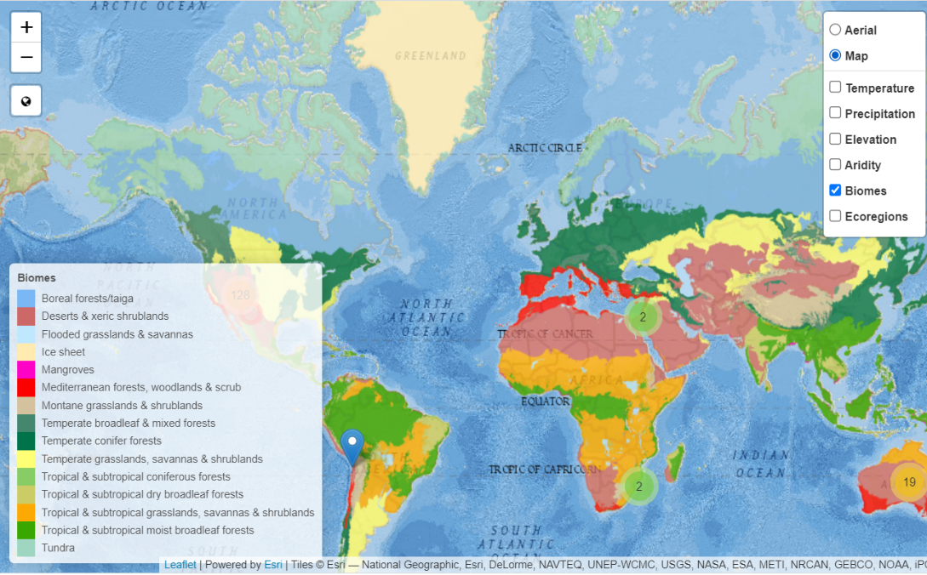
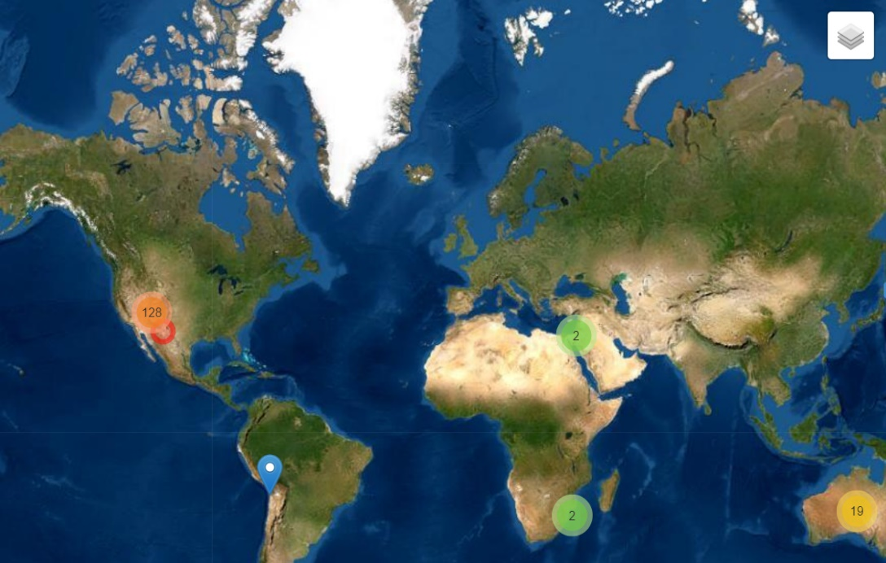
Changing Filters
Check these two boxes!
Click here!

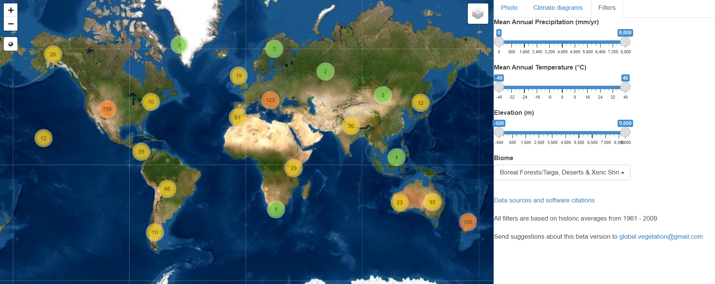
Setting Desert/Xeric Shrubland Filter
Click here!

Then click here!

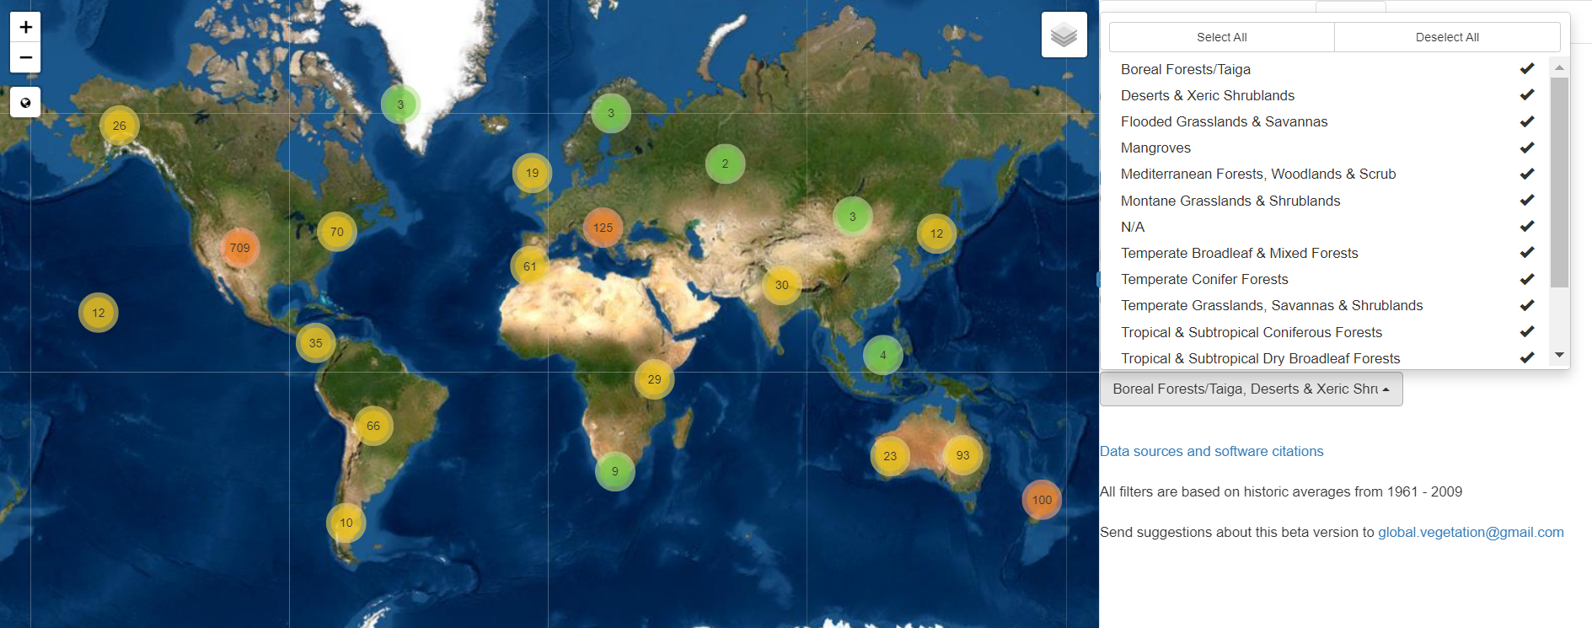
Click here!
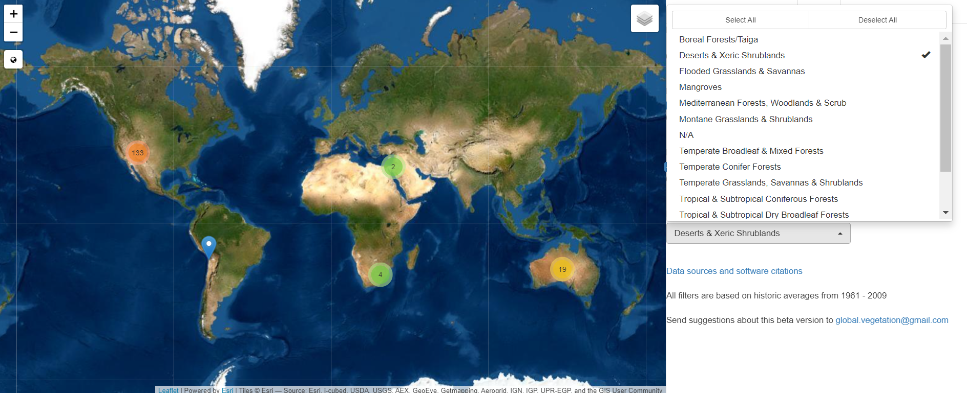
Finally, select “Deserts & Xeric Shrublands”!

Temperature and Precipitation graphic organizer
Data Set | This information may help make sense of the data. Generally, it will snow when average temperatures are below 2°C. Averages from 2-4°C may have mixes of rain and snow. Averages 5°C and above indicate mostly rain. Remember, precipitation is measured in mm. For context, an area is classified as a desert if it gets 250 mm or less of precipitation in a year. Forests and grasslands can have precipitation ranges from 250 mm to 2000 mm per year. Use the Whittaker biome diagram to analyze what biome your area represents.
 | What do the graphs and data tell you about the temperature in this region? How does it change throughout the year? | What do the graphs and data tell you about the precipitation in this region? How does it change? Would it be mainly snow, rain, or a mix?
Wyoming or Australia (Circle one)
Mystery Biome
How does the Mystery Biome compare to your initial data set?
Back to Inquiry 1
Observation Graphic Organizer
What did you observe? | What do these observations make you think about? | What questions do you have about each observation?
What do you observe about the location of different biomes in the world?

What do you observe about the location of desert biomes in the world?

What do you observe about the patterns of desert biomes?

What do you observe about other patterns of biomes on the global map?

Back_to_Inquiry_2

Desert Resources
Nat Geo Desert Types
ASU Deserts
NPS Deserts and Activities
Wild Classroom Deserts

Desert Diagrams
Hadley Cells and Subtropical Deserts
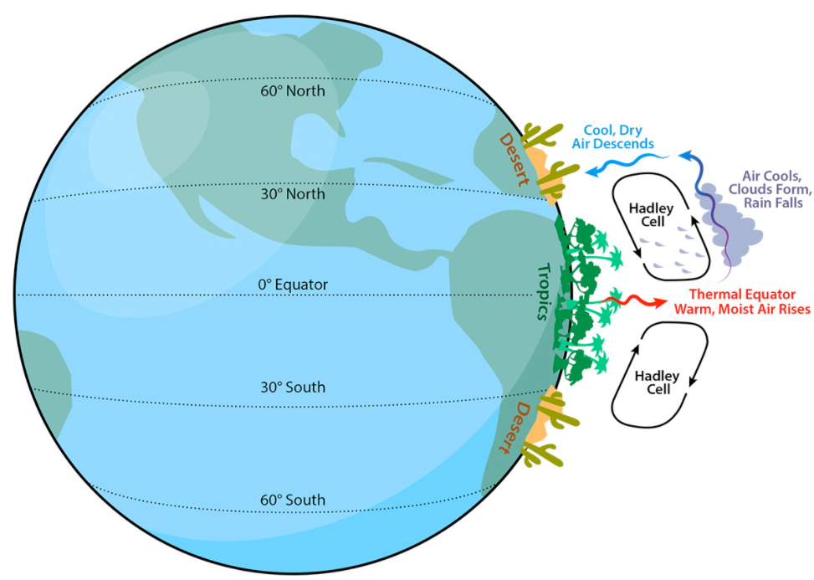
Image credit: https://askabiologist.asu.edu/explore/desert
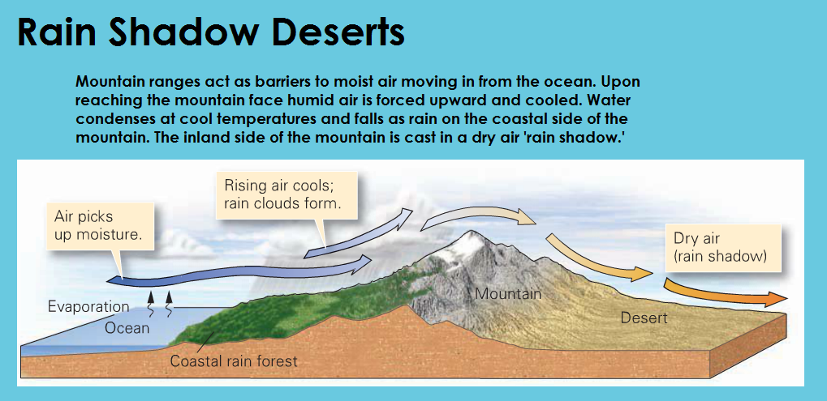
Image credit: https://sites.google.com/site/supercoolgeology/types-of-deserts/rain-shadow-deserts
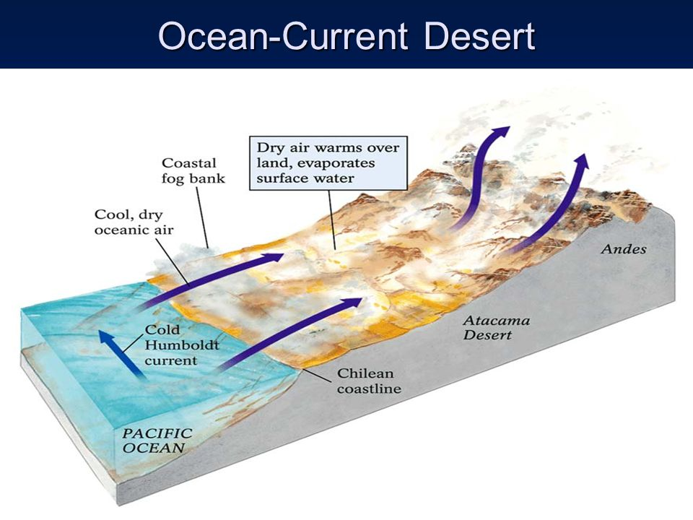
Image credit: https://slideplayer.com/slide/4320124/
Back_to_Inquiry_2

Presentation Information Sheet
Type of Desert | How does this desert form? | What is an example of this type of desert? | What other information did you find interesting about this type of desert?
Subtropical
Coastal
Interior
Rain Shadow

Back to Inquiry 2
Temperature and Precipitation graphic organizer
Data Set | For each season, describe the following: What would the weather be like? How much precipitation was there? Was the precipitation mainly rain or snow? Generally, it will snow when average temperatures are below 2°C. Averages from 2-4°C may have mixes of rain and snow. Averages 5°C and above indicate mostly rain. Remember, precipitation is measured in mm. For context, an area is classified as a desert if it gets 250 mm or less of precipitation in a year. Forests and grasslands can have precipitation ranges from 250 mm to 2000 mm per year. Use the Whittaker biome diagram to analyze what biome your area represents.
 | Winter (Jan. – Mar.) | Spring (April – June) | Summer (July – Sept.) | Fall (Oct. – Dec.)
Wyoming or Australia (Circle one)
Wyoming or Australia (Circle one)

Back to Inquiry 3
Plant Trait Graphic Organizer
Plant Name | Where is this plant found? (Wyoming or Australia) | How does this plant survive changes in precipitation? (Long periods of snow or drought, burst of rain, etc.) | How does this plant survive changes in temperature? (Extreme heat or cold, nonstop UV rays, etc.) | What other adaptations does this plant have to survive?

Back_to_Inquiry_3
Evidence, Argumentation, and Feedback Sentence Starters
Arguing From Evidence
I believe that (insert claim) because (use evidence from class)
When I looked up (insert idea or plant), I found that (insert evidence). This tells me that (insert claim).
Precipitation can have an impact on plant traits because (insert evidence here)
Temperature can have an impact on plant traits because (insert evidence here)
Complimenting, Critiquing, and Asking Questions
Thank you for sharing. I like that you said (restate classmates claim).
Thank you for sharing. I also noticed/agree with (claim you also saw or agree with).
I was a little confused by (insert classmate’s claim). Can you restate that?
I am interested in hearing a little more about (insert classmate’s claim). Can you explain it a little more deeply?
I do not agree with (insert classmate’s claim). I found (insert own claim/evidence).
I think I agree with your claim (insert classmate’s claim) but I am not sure what your evidence was. Can you back up your claim?
Back_to_Inquiry_3

References:
Moeller, K. (n.d.). Delving into deserts. Arizona State University. https://askabiologist.asu.edu/explore/desert

National Geographic. (n.d.). Desert. In National Geographic Resource Library. https://www.nationalgeographic.org/encyclopedia/desert/

National Park Service. (n.d.). Deserts. National Park Service. https://www.nps.gov/moja/learn/education/classrooms/upload/MDD-Unit-II-Deserts.pdf

The Wild Classroom. (n.d.). Desert Biome. The Wild Classroom. https://thewildclassroom.com/biomes/desert/

