This document provides a lesson outline using a phenomenon from the Global Vegetation Project (gVeg). Our intent is to provide you with a phenomenon from gVeg that you can use to stimulate discussion and lessons within your classroom. Bookmarks are present throughout the document to ease your navigation. Your class may take the phenomenon in many directions; we aim to anticipate a few of those directions and provide resources and ways to utilize gVeg. We also recognize that each educator has specific styles, student needs, time restraints, and outcomes to hit. This is intended to be a resource that fits your needs as an educator while sparking student interest and joy. Use this resource in whatever way best suits you!

Overarching Phenomenon: Individual plants and plant communities look similarly despite living far apart on the planet. Why does this happen? What is responsible for this?

Introduction and Background

Convergent evolution is the idea in biology that organisms may evolve the same or similar traits independent of one another. Often, these traits evolve in response to a set of similar conditions or challenges. An example of convergent evolution is evident in flying animals such as birds and bats. While both have evolved the trait of wings and the ability to fly, these traits evolved independently of one another. Convergent evolution contrasts divergent evolution, in which species share a common ancestor but evolve traits that make them a distinct species. For example, a hummingbird and a duck share the same basic wing structure but have evolved other traits that distinguish them.
In plant communities, convergent evolution can be observed as several different levels. One can observe convergent evolution at the species level, where two species may evolve the same trait independently of another in a completely different part of the globe. For example, cylindrical, succulent plants in both South America and Africa independently evolved modifications to the process of photosynthesis. Both types of plants evolved the CAM pathway of photosynthesis. This pathway involves plants only taking up carbon dioxide at night. During the day, it can utilize this stored carbon dioxide to photosynthesize while keeping its stomata shut. This adaptation allows these plants to be highly efficient at conserving water. This mechanism is observed in many species living in dry climates.
Species in both South America and Africa demonstrate this trait. These continents split from each other roughly 180-140 million years ago, so exchange of genetic information has been low since that time. CAM photosynthesis has evolved many times in many different plant lineages, indicating that this is a beneficial evolutionary pathway. This is a clear example of convergent evolution, as different plants evolved this trait independently.
On the community level, convergent evolution can also be observed in plants. The Mediterranean biome is characterized by the west or southern coasts of continents where cold ocean currents prevail. In these regions, the summers are dry while the colder seasons are generally more wet. There is only a small window in time where moisture is sufficient and temperatures are warm enough for ample growth. The plants in these regions throughout the globe have demonstrated examples of convergent evolution. The plants here are mostly shrubs with small evergreen leaves with thick cuticles, adapted to the dry seasons. Many of these plants are aromatic and also adapted to fire, especially since humans have been present on the landscape. These areas are quite distant from each other: The California coast, Chile, South Africa, Australia, and the area surrounding the Mediterranean Sea. However, the unique set of climatic conditions favors particular traits that many plants in these communities have evolved.

Information Sourced from:

Heyduk, K., Moreno-Villena, J.J., Gilman, I., Christin, P.-A., & Edwards, E. J. (2019). The genetics of convergent evolution: Insights from plant photosynthesis. Nat Rev Genet 20, 485–493. https://doi.org/10.1038/s41576-019-0107-5

Wet Tropics Management Authority. (n.d.). Gondwana: The break-up of pangea. Wet Tropics Management Authority. https://www.wettropics.gov.au/gondwana#:~:text=About%20180%20million%20years%20ago%20Gondwana%20was%20starting%20to%20break,from%20Australasia%2FIndia%2FAntarctica.

Woodward, S. L. (1997). Mediterranean Scrub. Biomes of the World: Radford University. https://php.radford.edu/~swoodwar/biomes/?page_id=98

Lesson Ideas

Below is a Phenomenon_Map which provides several lines of inquiry that your students may generate. Following that is a written framework for presenting the phenomenon, a plan for analyzing data, and several potential lines of student-generated inquiry that may develop. You may choose to go in any of those directions. Allow the students to guide the path of your teaching!

Phenomenon Map

The figure below maps a potential course for engaging students with the phenomenon and given material. The green bubbles are the activities described in this document and support by gVeg. The blue bubbles are potential lines of inquiry that this activity can serve as a starting point for; however, gVeg itself does not support these investigations directly. For these investigations, potential performance expectations (PE’s) are listed.
Community-level comparison: Mediterranean biomes

Phenomenon: Why are plants in different parts of the world so similar? What could result in this?
Factors impacting biodiversity in ecosystems
Potential PEs:
HS-LS2-2; HS-LS2-6

Species-level comparison and evolution of CAM pathways
Potential PEs:
HS-LS4-1; HS-LS1-5

Presentation of Phenomenon

*Note: Below are presented two different options for phenomena for exploring convergent evolution. One focuses a bit more on the species level while the other is at a community level. Both serve as a great introduction into convergent evolution. While this resource provides more support for community-level convergent evolution, the species-level comparison can support other lessons, especially connected to photosynthetic pathways.

Activities | Rationale
Send students to either set of links below:  Species level comparison:  Africa  South America  Community level comparison  Australia  South Africa  California  Italy  Regardless of what set of pictures students view, ask them to make observations about the plant communities there. You may use a few of these questions to guide them:  - What do you notice about the plants in these pictures?  - What do these plants remind you of?  - What surprises you about the plants in these pictures?  - What types of traits do these plants have that you can see? How might these traits help these plants survive?  - Why do you think the plants have some of these traits?  - What is similar about the plants or environment in these pictures? What is different? | Having students make observations at this point will help get their minds thinking about these locations and what commonalities they might see. They also might begin thinking of the adaptations these plants have and what those adaptations may be useful for. For example, they may see cactus-like plants in pictures and begin to think that these environments might be dry. Or students may notice that the plants are relatively low-growing, which might tell them something about the availability of moisture or nutrients. Allowing students to think, explore, and generate ideas and questions is the primary focus of this activity.
Have students share their observations in pairs. When finished sharing, have them share out to the whole class. Hopefully students begin to recognize some of the similarities between the plant communities. Pose the phenomenon question: “Why do these plants look similar despite living so far apart? What do you think can explain that?” Have students discuss in pairs or small groups. Then, collect any thoughts, ideas, or questions at the front of the room. | By posing the phenomenon question, students now must begin to think about why they observed what they did. Students have the opportunity to think through things and make their thinking process visible. By collecting thoughts and questions, you may determine the proper way in which to steer the lesson. If students begin to discuss ideas on a community plant level, you may choose to pursue the lesson below. If students begin discussing ideas surrounding individual plant traits, you may choose to explore photosynthetic CAM pathways.

Lesson Ideas

Below are the Performance Expectations, Science and Engineering Practices, Crosscutting Concepts, and Disciplinary Core Ideas present in this lesson. The color coding is in line with the Next Generation Science Standards (NGSS). The color coding is consistent throughout the document, reflecting where each of the three dimensions are present.

Performance Expectations | HS-LS4-4. Construct an explanation based on evidence for how natural selection leads to adaptation of populations.
Science and Engineering Practices | Constructing Explanations and Designing Solutions  Construct an explanation based on valid and reliable evidence obtained from a variety of sources (including students’ own investigations, models, theories, simulations, peer review) and the assumption that theories and laws that describe the natural world operate today as they did in the past and will continue to do so in the future.
Crosscutting Concepts | Cause and Effect  Empirical evidence is required to differentiate between cause and correlation and make claims about specific causes and effects.
Disciplinary Core Ideas | Adaptation  Natural selection leads to adaptation, that is, to a population dominated by organisms that are anatomically, behaviorally, and physiologically well suited to survive and reproduce in a specific environment. That is, the differential survival and reproduction of organisms in a population that have an advantageous heritable trait leads to an increase in the proportion of individuals in future generations that have the trait and to a decrease in the proportion of individuals that do not. Changes in the physical environment, whether naturally occurring or human induced, have thus contributed to the expansion of some species, the emergence of new distinct species as populations diverge under different conditions, and the decline–and sometimes the extinction–of some species.

Lesson Progression: Community-level convergent evolution

In this lesson, students view locations in the Mediterranean biome in four different locations. Students will make observations on these plant communities and compare this to climate data and information. Students will make claims connecting the climatic conditions to the plant adaptations using gVeg and other resources. Students will then make predictions as to how the plant community may change with changing climate.

Activities | Rationale
See the phenomenon exploration for the four sites within the Mediterranean climate. If you did not use these, have them look at the four pictures linked below.  Australia  South Africa  California  Italy  You may choose to ask a few targeted questions here, such as:  - What similarities do you see in the landscape in these locations? What differences do you see?  - What is similar or different about the locations of these areas on the world map?  - Based on the pictures, what do you expect the weather to be like in these places? How might the location of these places cause different weather patterns?  There is an option here if you want to have students focus on individual pictures. If so, have students make observations on their picture and then get into groups of four, with each picture represented. Students can share their observations. | Now that students have hopefully explored these pictures, they can begin to explore in a bit more detail. The questions here get students thinking a step backward, considering the climate and potentially global patterns of climate. While they may not be able to explain why these climates are so similar, they may begin to see similarities in that these places are along the coasts and along similar latitudes above and below the equator.
For each picture, several different plant species are linked. Most of these links go to iNaturalist pages that give some detailed information about these plants including life history and characteristics. Have students view at least one plant at each site. Students will look at the various adaptations these plants have, beginning to think about the type of environment these plants may live in. You may prompt students with these questions:  - What are some of the traits you observed from these plants?  - What are some similarities you see amongst the plants in these areas?  - How might the environment these plants live in effect the traits that are most dominant? | By exploring these plants up close, students can begin to see some of the adaptations and traits they share. Many of these plants are succulent or hardy plants that demonstrate adaptation to dry conditions. While students have not yet investigated climate yet, hopefully they begin to see patterns that these plants are shrub-like and well-adapted to periods without water.
Have students consider both the Walter-Lieth and Whittaker Biome diagrams under the “Climate Diagrams” tab. Below are some tips for accessing this tab. Prompt students to consider what these climate diagrams tell them about each location. The graphic organizer below might be helpful. Students will use these observations as evidence as they later explain why the plants may be particularly adapted to these regions. Both the Walter-Lieth and Whittaker Diagram guides on the lesson resources page will also assist students in making sense of the diagrams. | The climate diagrams serve as an entry point into connecting climate and plant adaptations. For all of these regions, students can see that there is a dry period during the year. While some areas may have more significant drops or increases in moisture, that is a common theme throughout. Students may also notice the differences in moisture availability by hemisphere. This could serve as a discussion point for how seasons differ by hemisphere and for a larger view of Earth and its rotation around the Sun.
Based on their evidence, have students answer questions that begin to explain the relationship between climate and plants. They may do so independently or in pairs/groups:  - What similarities do you see in the climate of the four areas?  - What differences do you see in the climate of the four areas?  - How do you think the climate effects the adaptations of the plants that live there? | Students can begin to make connections in this part. They have investigated plant traits and now the environment. They can now start synthesizing this information into a more cohesive explanation. Hopefully students begin to make clear connections between the adaptations for water retention and relatively low moisture in these environments with extensive warm, dry periods. They should see that despite these locations being far apart, the climate provides similar challenges that plants have adapted to. This allows students to draw explicit connections between the types of environments these plants live in and how that environment impacts the characteristics that are expressed in a plant population.
You may introduce the term “convergent evolution” to students if this is not something you have covered in class before. Providing a few examples to students from the animal kingdom, such as bird and bat wings, may be helpful in establishing an analogy. After a short explanation, have students consider this question:  - How might convergent evolution be related to the phenomenon we observed here?  Students should be prompted to use the evidence they have collected during this activity to support their explanation. They now have evidence from a variety of sources, further bolstering their arguments. | While students may have articulated the relationship between adaptation and environment already, this puts a term to it. Hopefully analogies from other life forms clicks for students and they can begin to see that plants respond in the same way. The environment provides challenges for plants, and in response, particular traits become more pronounced. This can happen in areas that are not particularly close to each other, as in this phenomenon.
In closing, pose some cause-and-effect questions to students that will get them thinking of how plant communities may respond to long term changes in climate. You may choose a variety of questions to ask. Some sample questions are found below:  - If climate begins to change and these climates begin to experience longer periods of precipitation, what changes to characteristics would you expect to occur in the plant communities?  - If climate begins to change and these climates begin to experience longer dry periods, what changes to characteristics would you expect to occur in the plant communities?  - If the Southern Hemisphere experiences periods of moisture while the Northern Hemisphere experiences more drought, how might the plants at these sites change? Would you expect similar results at each site? Why or why not?  All explanations should be backed by evidence students have collected. | Students have the opportunity in this part to apply their knowledge to novel situations. Hopefully students will be able to explore how change may impact plant communities in the future. If precipitation increases, there may be a decrease in succulents or hardier plants in these regions, favoring more water adapted plants. On the other hand, if these regions experience drought, we might expect an increase in succulents and a transition to something more desert-like in appearance. In terms of differing hemispheres, students should recognize that even though these communities are similar now, that might not be the case if conditions change between them. Students should hopefully be able to recognize that evolution is a continually ongoing process and that plants that are best adapted to an area will succeed there.
Return to the original phenomenon question: “Why do these plants look similar despite living so far apart? What do you think can explain that?” Students should be able to synthesize evidence from throughout the lesson. Record students’ new ideas, thoughts, and potentially new questions. These new questions may stimulate other lines of inquiry. | You can now see the changes in students’ understanding after engaging the material. Hopefully students use evidence from the lesson and new understanding of convergent evolution. The new questions or ideas they generate may provide guidance for your next lesson. See the phenomenon map for potential ideas of where to steer the lesson next.

Resources
Accessing Climate Diagrams
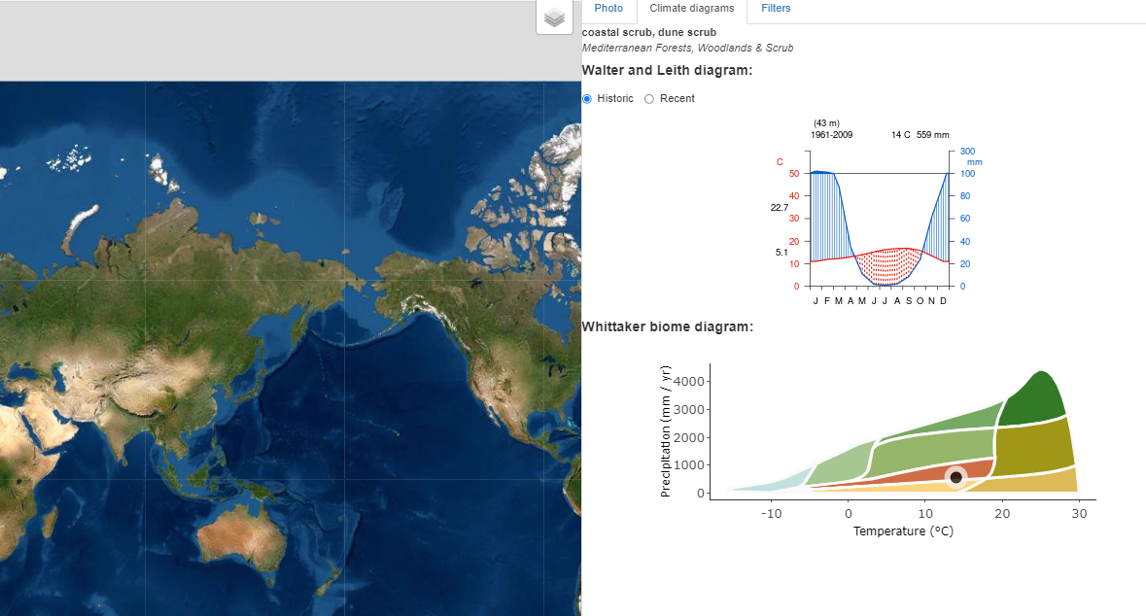
Click here!

Climate Investigation Graphic Organizer
Location | Consider this when describing the climate for each area. Generally, it will snow when average temperatures are below 2°C. Averages from 2-4°C may have mixes of rain and snow. Averages 5°C and above indicate mostly rain. Remember, precipitation is measured in mm. For context, an area is classified as a desert if it gets 250 mm or less of precipitation in a year. Forests and grasslands can have precipitation ranges from 250 mm to 2000 mm per year. Use the Whittaker biome diagram to analyze what biome your area represents.
 | What does the Walter-Lieth diagram tell you about the climate here? | When is it dry in this area? When is there more precipitation? | What does the Whittaker Biome diagram tell you about this location?
Italy
South Africa
California
Australia

